WORK IN PROGRESS

Team Members:

Hemanta Bikram Singh  
Diwakar Darlami  
Ayush Bajgai  
Rabin Balayar  
Arbindra Kumar Sah

**Table of Contents**

1. **Initiation Phase**
   1. **Project Charter**

* Version Control
* Project Justification
* Project Scope
* Project Assumption
* Rules & Responsibilities
  1. **Meeting Minutes**

1. **Planning Phase**
   1. **Belbin Analysis**

* Team Belbin’s Analysis
* Individual Belbin’s Analysis
  1. **Skills Audit**
* Team Skills Audit
* Individual Skills Audit
  1. **Project Management (MS Project)**
* Gantt Chart
* Network Diagram
* Timeline
* Calendar
* Resource Sheet
* Change Working Time
  1. **Communication Tool Used**

1. **Execution**
   1. **Entity Relationship Diagram**

* EERD
* ERD
* Final Composite
* Logical Table
  1. **Use Case Diagram**
* Overview Use Case Diagram
* Customer Use Case Diagram
* Trader Use Case Diagram
* Admin Use Case Diagram
  1. **Requirement Catalogue**
* Functional Requirement
* Non-Functional Requirement
  1. **Logo Design**
  2. **Wireframe**
  3. **Product Development**
* Website Homepage
* Login pop up
* About us

1. **Initiation Phase**
   1. **Project Charter**

|  |
| --- |
| Title: Cleck Shop  Project Manager: Rohit Raj Pandey  Sponsor: The British College  Customer: Butchers, Greengrocer, Fishmonger, Bakery and Delicatessen. |

Version Control

|  |  |  |
| --- | --- | --- |
| Version | Date | Summary of changes |
| 1 | 2nd May, 2021 | *Initial Project Plan ( 1st Draft, Changes will be made if necessary or requirement is needed)* |
| 2 | Any date when amended | We'll keep you informed of any updates we make. |

Project Justification

|  |
| --- |
| *Cleck Shop is an online marketplace that is created to promote the small local businesses from the suburbs of Cleckhuddersfax by considering the aspect of time and effort of traders and helping the customers to shop while from their home with a click of a button. Cleck Shop allows customers to purchase products during their working hours and beyond the opening hours of local shops hence increasing the sales for traders and providing shopping convenience to the customers.*  *As the competition rises the local traders are finding it hard to keep up. Cleck Shop will be helping those small independent shops to up their level and keep up with the international chains. Having the benefit of an online marketplace the traders can save their shop maintenance and advertisement fee and have to spend much less in physical outlook. This market place shall allow the traders to sell all their goods online and take orders from the customers even while their shops are closed. The reach of the shop will not be limited to just the locals nearer to that shop as the online marketplace will be available to all people within Cleckhuddersfax. And it will provide them with wider scope to expand their business beyond the suburb when the marketplace expands in near future. Traders can easily list the variety of items available in their shops and manage their stock, providing better options for customers to choose from the large product collection. Traders can provide detailed description, price details and stock availability about their products. They will also be able to receive valuable feedback from the buyers which shall help the sellers to improve accordingly. Also, they can easily manage their inventory as they will be provided with a proper dashboard that allows them to edit, update and delete their product details. Sellers do not need to maintain physical account books as all transactions are recorded and receipts are generated automatically. They will also receive money directly into their online account that makes money management easier. Sellers can clear their unsold stock by providing various sales and offers. They can also get a range of daily and periodic reports of their sales that help in analysing profit or loss which helps to change or make a better business strategy.*  *Instead of driving to the mall or going out to shop, buyers can purchase goods at Cleck Shop as it is a one stop online marketplace with a variety of goods ranging from green groceries to delicacies. This marketplace can be available on multiple platforms so anyone with a smart gadget can place an order. Customers can order their desired products from their preferred local shop at any time and onto their preferred location even if they are at work or outside the suburb. This shall help the buyers to navigate between different product categories and choose from a wide variety of products with various selection options. Also, they can buy the products from various stores located throughout Cleckhuddersfax which are slightly away from their street. The cost price, product description along with an image of the goods that are being sold will also be available to the customers and they can easily compare and choose between the products. Buyers can also leave reviews for the traders regarding their products and rate it according to their satisfaction that helps other buyers to analyse whether to purchase the product depending on reviews. Customers can receive their delivery directly at their accommodations or their alternative address. In case the customer is not available their products can be left at the doorstep. If the buyers are dissatisfied with the purchase or if they receive defective products, they will be provided with the service of easy return. As purchasing from an easy portal there will be easy payment modes like having Paypal and Stripe for payment gateway. They can also choose the delivery day and the time from the slot collection. This will make shopping easier and convenient for the customers.*  *Considering all the reasons that both the customers and traders receive from this project, Cleck Shop will be benefiting everyone. As the project promotes the local small independent businesses this will help in the growth of the local economy. Since all the traders are contributing to the same project, this will create a unity among the locals of Cleckhuddersfax .The local shops will be able to compete with the international chains in their area effortlessly. Buying and selling will be more convenient and also simple for customers and local traders respectively. This will also help to live a quality life to business owners as they need to spend less time in their store. As a result, the Cleck Shop will be able to boost sales and expand its activities. In conclusion, with an online platform, customers can place orders online 24/7 with fast delivery. Thus it provides a simple, fast and convenient ordering system.* |

Project Scope

|  |
| --- |
| ***Major Objectives***   * *To design, create and maintain a sustainable, responsive and dynamic web-based platform.* * *To implement an e-commerce platform for selling products based on groceries, bakery, fishmonger, butchers and delicatessen within the suburb of Cleckhuddersfax.* * *To promote the online marketplace and build customer relationships through word of mouth, referral, digital marketing and networking.* * *Improving the user interface with more enhancing features, user friendly and easy to use.* * *To Increase the flow of customers with increase in sales and profit turnover.* * *To increase trader’s sales with the least effort and also saving their valuable time.* * *To deliver the order within the collection slot selected by the user.* * *To unite local stores to compete against national chains.* * *To provide proper analysis of data and reports.* |
| ***Customer Interface***   * *To navigate products by shop or by category* * *Registration and Login system* * *Ability to add to cart* * *Able to edit their Personal Information* * *May have multiple billing and mailing address* * *Receives e-invoice* * *Product reviews and ratings* * *Shop ratings* * *Product variations (quantity, colours etc.)* * *Ability to share on social media platforms*     ***Trader Interface***   * *Registration and Login system* * *Ability to add a product* * *Grant variants such as colours, weight and quantity etc.* * *Ability to edit a product* * *Ability to delete a product* * *Provide sales and offers* * *Able to view daily and weekly reports*     ***Management Interface***   * *Registration and Login system* * *Has APIs for PayPal and Stripe* * *Allows management to access all Shop goods* * *Generates a discount code* * *Provides daily, weekly, monthly reports of the goods* * *Keep the track of goods that needs to be delivered* * *Provides transaction details* |

Duration

|  |
| --- |
| *Start Date: 2nd May 2021*  *WIP: 7th June 2021*  *Team Portfolio: 12th July 2021*  *Final Presentation: 2nd July 2021* |

Estimated Budget

|  |  |
| --- | --- |
| Ayush Bajgai | Working days: 7  Working Hour: 1hr  Total Hours: 7hr * 10 weeks = 70 Hrs |
| Hemanta Bikram Singh | Working days: 7  Working Hour: 1hr  Total Hours: 7hr * 10 weeks = 70 Hrs |
| Rabin Balayar | Working days: 7  Working Hour: 1hr  Total Hours: 7hr * 10 weeks = 70 Hrs |
| Diwakar Darlami | Working days: 7  Working Hour: 1hr  Total Hours: 7hr * 10 weeks = 70 Hrs |
| Arbindra Kumar Sah | Working days: 7  Working Hour: 1hr  Total Hours: 7hr * 10 weeks = 70 Hrs |
| Total: 350 Hours |

Roles and Responsibilities

|  |  |
| --- | --- |
| Name | Role |
| *Ayush Bajgai* | *Primary role(Resource Investigator), Secondary role(Specialist) and least likely (Shaper)* |
| *Hemanta Bikram Singh* | *Primary role(Specialist), Secondary role(Co-ordinator) and least likely (Implementer)* |
| *Diwakar Dalami* | *Primary role(Monitor Evaluator), Secondary role(Resource Investigator) and least likely (Team Worker)* |
| *Arbindra Shah* | *Primary role(Plant), Secondary role(Resource Investigator) and least likely (Complete Finisher)* |
| *Rabin Balayar* | *Primary role(Co-ordinator), Secondary role(Monitor Evaluator) and least likely (Shaper)* |

1.2 Meeting Minutes

|  |  |  |  |
| --- | --- | --- | --- |
| Meeting No. | Date | Time | Topics |
| 1 | May 02 | 9:00 pm - 11:00 pm | * Discussion on Project Charter |
| 2 | May 03 | 2:30 pm - 4:00 pm | * Discussion on Project Charter |
| 3 | May 04 | 1:00 pm - 6:00 pm | * Completion of Project Charter * Initial discussion on Team Contract |
| 4 | May 05 | 11:00 am - 4:30 | * Completion of Team Contract |
| 5 | May 09 | 1:30 pm- 2:30 pm | * Discussed  about the required skills for audit |
| 6 | May 12 | 1:30 pm - 4pm | * Completion of skill audit (Team) |
| 7 | May 16 | 2:00 pm - 3:00 pm | * ERD |
| 8 | May 17 | 9:00 pm - 12 pm | * Erd completion * Eerd |
| 9 | May 18 | 9:30 am - 12:30pm | * Completion  of eerd |
| 10 | May 20 | 4:00 pm - 5:00 pm | * Final edit on erd and eerd |
| 11 | May 22 | 4:00 pm - 5:00 pm | * Completion of erd, composite erd, eerd and logical table |
| 12 | May 24 | 4:00 pm - 7:00 pm | * Logo design * Wireframe discussion |
| 13 | May 25 | 4:00pm - 6:00 pm | * Completion of logo |
| 14 | May 26 | 6:00 pm - 8:00 pm | * UML completion |
| 15 | May 29 | 2:00 pm - 3:00 pm | * Product Development |
| 16 | June 3 | 4:00 pm - 6:00 pm | * MosCoW Functional Requirements |
| 17 | June 8 | 4:00 pm - 6:00 pm | * MosCoW functional and non functional completion |
| 18 | June 10 | 3:00 pm - 6:00 pm | * MS project |
| 19 | June 11 | 11:00 pm - 2:00 pm | * Presentation slide, ms project, Work in progress Documentation |

**2. Planning Phase**

2.1 Belbin’s Analysis

Team Belbin’s Analysis

|  |  |  |
| --- | --- | --- |
| Version:1.0 **Belbin’s Analysis** Date reviewed: 05/05/2021 | | |
| Primary role | Hemanta Bikram Singh | Specialist |
| Diwakar Darlami | Monitor Evaluator |
| Ayush Bajgai | Resource Investigator |
| Rabin Balayar | Co-ordinator |
| Arbindra Kumar Sah | Plant |
| Secondary role | Hemanta Bikram Singh | Co-ordinator |
| Diwakar Darlami | Resource Investigator |
| Ayush Bajgai | Specialist |
| Rabin Balayar | Monitor Evaluator |
| Arbindra Kumar Sah | Resource Investigator |
| Least Likely role | Hemanta Bikram Singh | Implementer |
| Diwakar Darlami | Team Worker |
| Ayush Bajgai | Shaper |
| Rabin Balayar | Shaper |
| Arbindra Kumar Sah | Complete Finisher |

Individual Belbin’s Analysis

|  |  |  |
| --- | --- | --- |
| Version:1.0 **Belbin’s Analysis** Date reviewed:05/05/2021 | | |
| Primary role | Arbindra kumara sah | Plant |
| Secondary role | Arbindra kumar sah | Resource Investigator |
| Least likely role | Arbindra kumar sah | Complete Finisher |

2.2 Skills Audit

Team Skills Audit

|  |  |  |  |  |  |  |  |
| --- | --- | --- | --- | --- | --- | --- | --- |
|  |  |  |  |  |  | **Skill Level: 1 (No Knowledge) - 5 (Competent)** | |
|  |  |  |  |  |  |
|  | **Date Reviewed: 9th May 2021** | | **Completed By: Clerk Shops** | **Version: 1.0** |  |
|  |  |  |  |  |  |
| NO# | Skill Required | Skill Level ( 1- 5) | Traning Action | Training Objective | Time (hrs) | Training Completion Deadline | Training for? |
| 1 | PHP Programming | 3 | Follow E-commerce web site PHP tutorial on Youtube, research on various websites and review through Level 5 | Become more confident in the use of PHP and in particular in the building of login, register, shopping carts, report creation and perform CRUD operations | 75 | 6/5/2021 | Arbindra Sah, Ayush Bajgai, Rabin Balayar |
| 2 | HTML | 3.6 | Go through https://www.w3schools.com/ | To build the complete structure of webpage | 23 | 5/25/2021 | Arbindra Sah, Diwakar Darlami, Rabin Balayar |
| 3 | CSS | 2.8 | Follow tutorial on Youtube, research on various websites and go through https://www.w3schools.com/ | To stylize and complete the webpage to make it attractive and responsive | 42 | 5/30/2021 | Arbindra Sah, Ayush Bajgai, Diwakar Darlami, Rabin Balayar |
| 4 | Bootstrap | 1.6 | Go through https://getbootstrap.com/ | To be more proficient in making webpage faster and responsive | 66 | 6/5/2021 | Arbindra Sah, Diwakar Darlami, Hemanta Bikram Singh |
| 5 | Photoshop | 4 | Follow tutorial on Youtube | To create banners, logos, adjust images size, thumbnails | 17 | 5/23/2021 | Arbindra Sah, Ayush Bajgai, Hemanta Bikram Singh |
| 6 | Illustrator | 4 | Follow tutorial on Youtube | To create vector images and logos | 17 | 5/23/2021 | Arbindra Sah, Ayush Bajgai, Hemanta Bikram Singh |
| 7 | Javascript | 1.4 | Research on various websites, follow tutorial on Youtube, review through slides and notes provided by University on Level 4 | Become more confident in the use of Javascript and implement complex features on webpage, displaying animated graphics, content updates, pop ups | 89 | 6/5/2021 | Arbindra Sah, Ayush Bajgai, Diwakar Darlami, Rabin Balayar |
| 8 | Oracle | 2.8 | Research on various websites, follow tutoiral on Youtube, review through slides and notes provided by University on Level 4 and Level 5 | Become more proficient in storing data, managing reports, graphs, charts | 40 | 6/1/2021 | Arbindra Sah |
| 9 | QSEE | 3.8 | Review through Level 4 | To make UML, ERD, Use Case diagram, DFD and Class Diagram | 12 | 5/18/2021 | Arbindra Sah, Ayush Bajgai |
| 10 | MS Word | 4.2 | Follow tutorial on Youtube and Google | To make text, document interactive with different tools and features | 6 | 5/17/2021 | Arbindra Sah |
| 11 | MS Excel | 4.2 | Follow tutorial on Youtube and Google | To make text, document interactive with different tools and features | 6 | 5/17/2021 | Arbindra Sah |
| 12 | MS Powerpoint | 4.2 | Follow tutorial on Youtube and Google | To make an attractive presentation slides | 6 | 5/17/2021 | Arbindra Sah |
| 13 | API | 1 | Research on various websites, follow tutorials websites on Youtube and go through https://developer.paypal.com and https://stripe.com/docs/api | To connect payment gateway of PayPal and Stripe to our website | 63 | 6/5/2021 | Arbindra Sah, Ayush Bajgai, Diwakar Darlami, Hemanta Bikram Singh, Rabin Balayar |
| 14 | Apache | 3.3 | Review through Youtube and Google | Become more confident in creating local servers | 6 | 5/28/2021 | Arbindra Sah, Ayush Bajgai, Diwakar Darlami |
| 15 | Sandbox | 1 | Research on various websites, follow tutorials websites on Youtube and go through https://developer.paypal.com and https://stripe.com/docs/api | To test the behavior of your payment gateway (e.g. PayPal, Stripe) after submitting the form and finding the best settings | 63 | 6/5/2021 | Arbindra Sah, Ayush Bajgai, Diwakar Darlami, Hemanta Bikram Singh, Rabin Balayar |
| 16 | Discord | 3.9 | Follow tutorials on Youtube | To make communication more easy, convinent among team members | 5 | 5/15/2021 | Arbindra Sah, Hemanta Bikram Singh |
| 17 | Adobe XD | 1.8 | Follow tutorials on Youtube | Become more proficient in creating wireframe | 15 | 5/22/2021 | Arbindra Sah |

|  |  |  |  |  |  |  |  |
| --- | --- | --- | --- | --- | --- | --- | --- |
| **Skills Audit (Individual)** | | | | | | | |
|  |
|  |  |  |  |  |  | **Skill Level: 1 (No Knowledge) - 5 (Competent)** | |  |
|  | **Date Reviewed: 9th May 2021** | | **Completed By: Arbindra sah** | **Version: 1** |  |  |
|  |  |  |  |  |  |  |
| NO# | Skill Required | Skill Level ( 1- 5) | Traning Action | Training Objective | Time (hrs) | Training Completion Deadline | Training for? |  |
| 1 | PHP Programming | 2 | follow E-commerce website php tutorial on youtube | to make the website fully dynamic | 18 | 05/06/2021 | Arbindra Sah |  |
| 2 | HTML | 3 | see MDN web tutorial | To build the complete structure of website | 6 | 15/05/2021 | Arbindra Sah |  |
| 3 | CSS | 2 | see MDN web tutorial | To stylize and make the website beauty | 12 | 20/05/2021 | Arbindra Sah |  |
| 4 | Bootstrap | 1 | revise the course of l4 | To be more proficient in making webpage faster and responsive | 15 | 30/05/2021 | Arbindra Sah |  |
| 5 | Photoshop | 3 | follow photoshop tutorial on youtube | To create banners, logos, adjust images size, thumbnails etc | 5 | 23/05/2021 | Arbindra Sah |  |
| 6 | Illustrator | 3 | follow illustrator tutorial on youtube | To create vector images and logos | 5 | 23/05/2021 | Arbindra Sah |  |
| 7 | Javascript | 1 | see MDN web tutorial and follow project related videos on youtube | to make the website more interactive | 20 | 25/05/2021 | Arbindra Sah |  |
| 8 | Oracle | 2 | follow w3 school and tutorial on youtube | Become more proficient in storing data, managing reports, graphs, charts | 10 | 30/05/2021 | Arbindra Sah |  |
| 9 | QSEE | 3 | revise the course of l4 and note of sad and tutorial on youtube | To make UML, ERD, Use Case diagram, and Class Diagram | 4 | 18/05/2021 | Arbindra Sah |  |
| 10 | MS Word | 3 | follow ms word tutorial on youtube | To make text, document interactive with different tools and features | 2 | 17/05/2021 | Arbindra Sah |  |
| 11 | MS Excel | 3 | follow ms excel tutorial on youtube | To make text, document interactive with different tools and features | 2 | 17/05/2021 | Arbindra Sah |  |
| 12 | MS Powerpoint | 3 | follow ms powerpoint tutorial on youtube | To make an attractive presentation slides | 2 | 17/05/2021 | Arbindra Sah |  |
| 13 | API | 1 | follow API tutorial on web | To connect payment gateway of PayPal and Stripe to our website | 15 | 05/06/2021 | Arbindra Sah |  |
| 14 | Apache | 3 | follow apache on youtube | Become more confident in creating local servers | 2 | 23/05/2021 | Arbindra Sah |  |
| 15 | Sandbox | 1 | follow sandbox on web and tutorial on youtube | To test the behavior of your payment gateway (e.g. PayPal, Stripe) after submitting the form and finding the best settings | 15 | 05/06/2021 | Arbindra Sah |  |
| 16 | Discord | 3 | Follow tutorials on Youtube | To make communication more easy, convinent among team members | 1 | 15/05/2021 | Arbindra Sah |  |
| 17 | Adobe XD | 1 | Follow tutorials on Youtube | Become more proficient in creating wireframe | 5 | 22/05/2021 | Arbindra Sah |  |

2.3 Project Management

Gantt chart

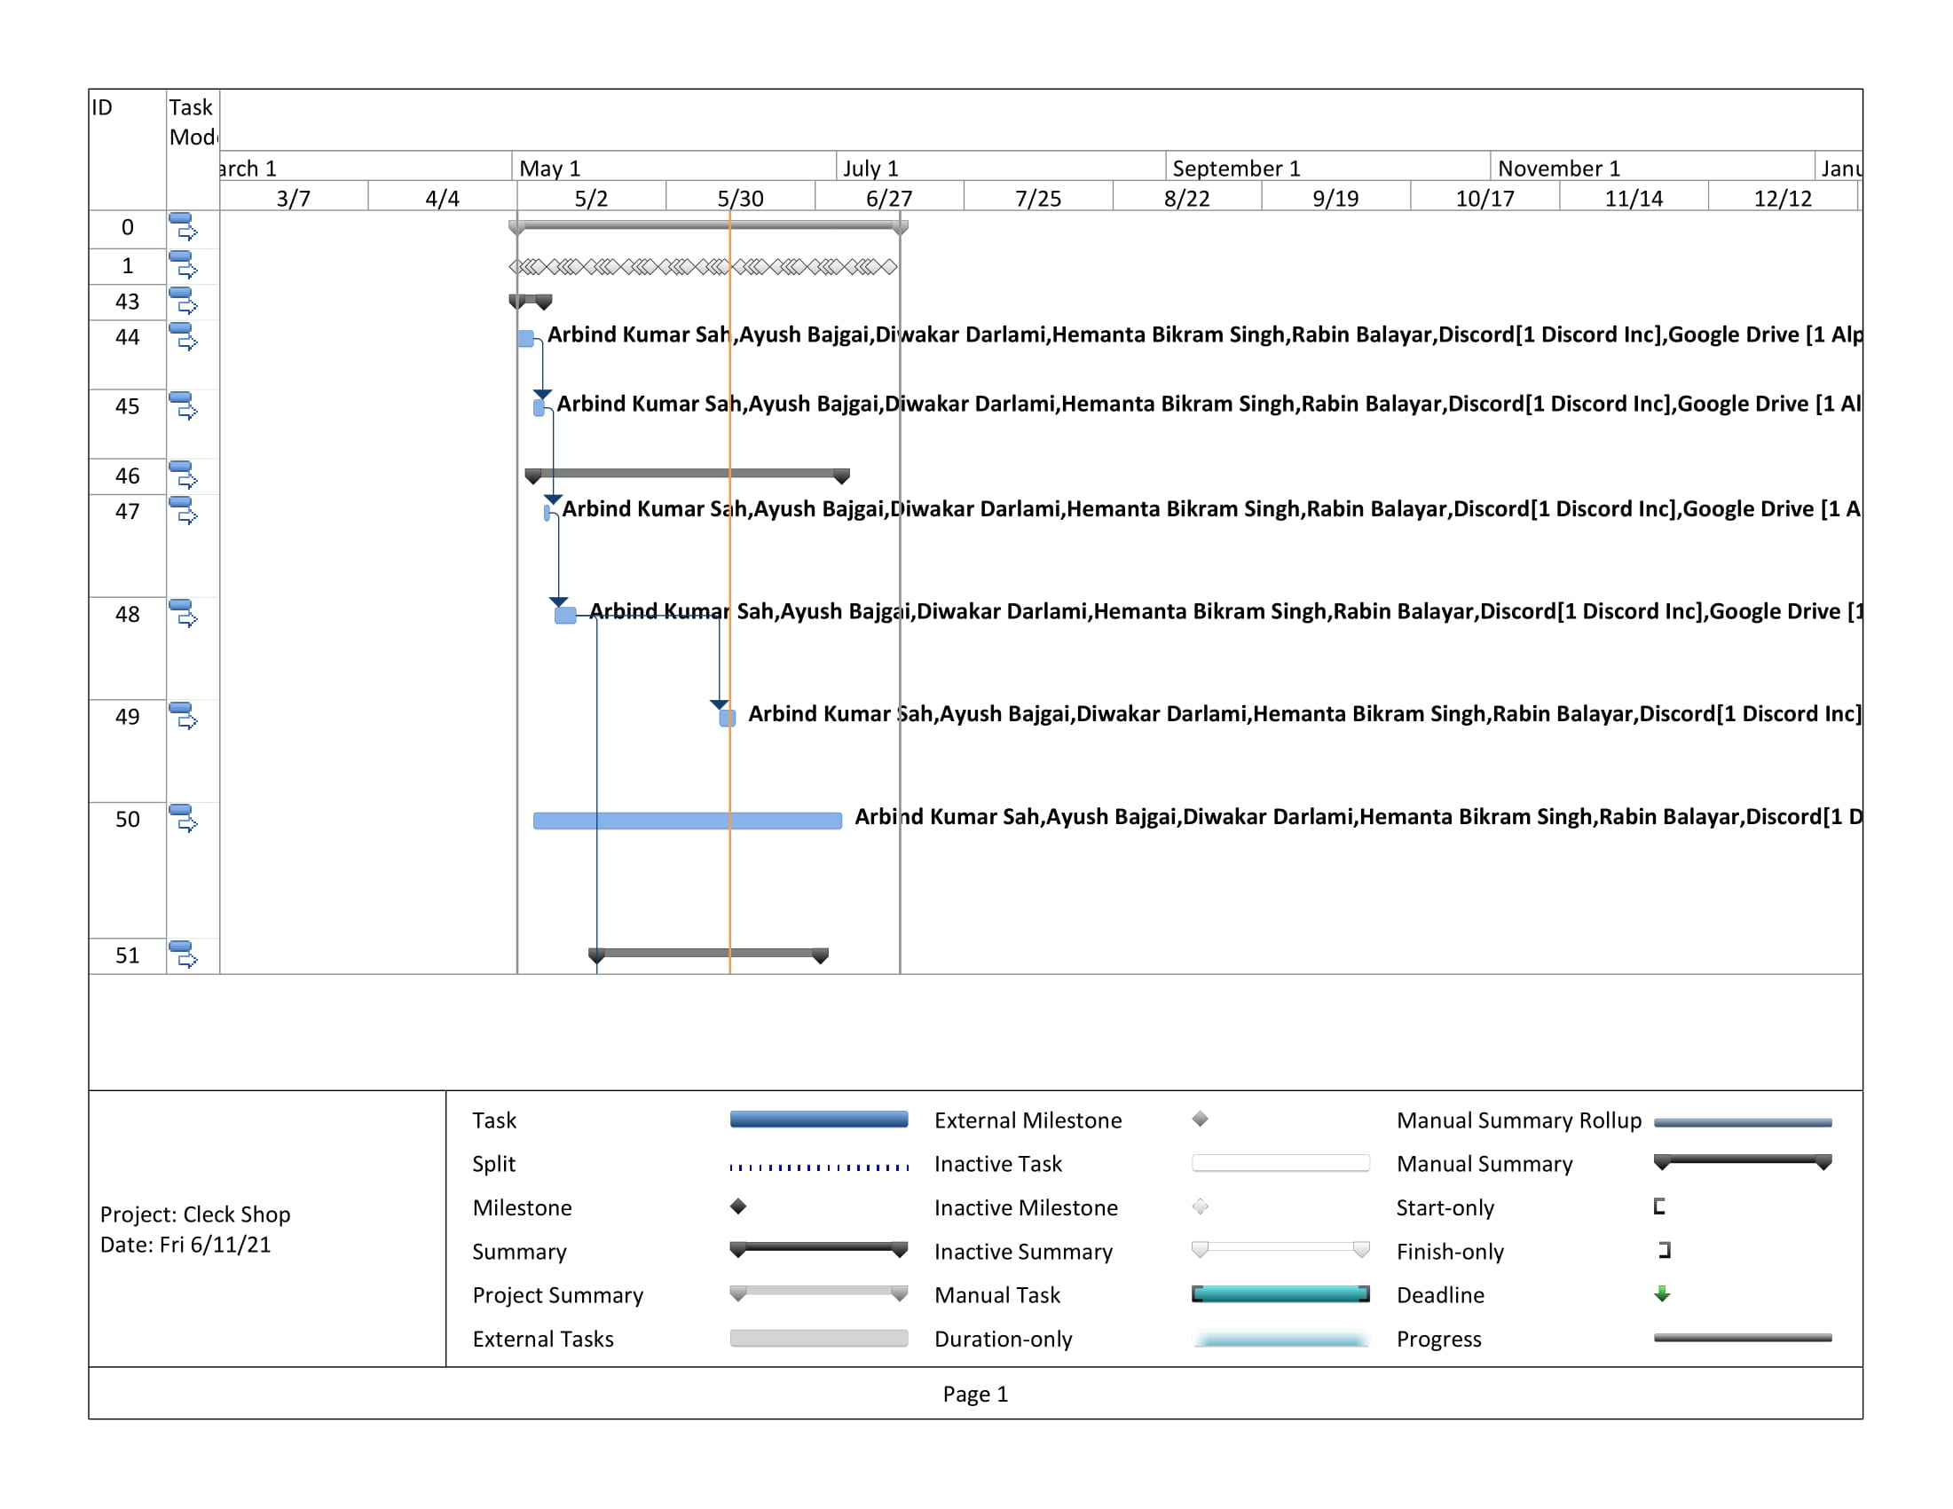

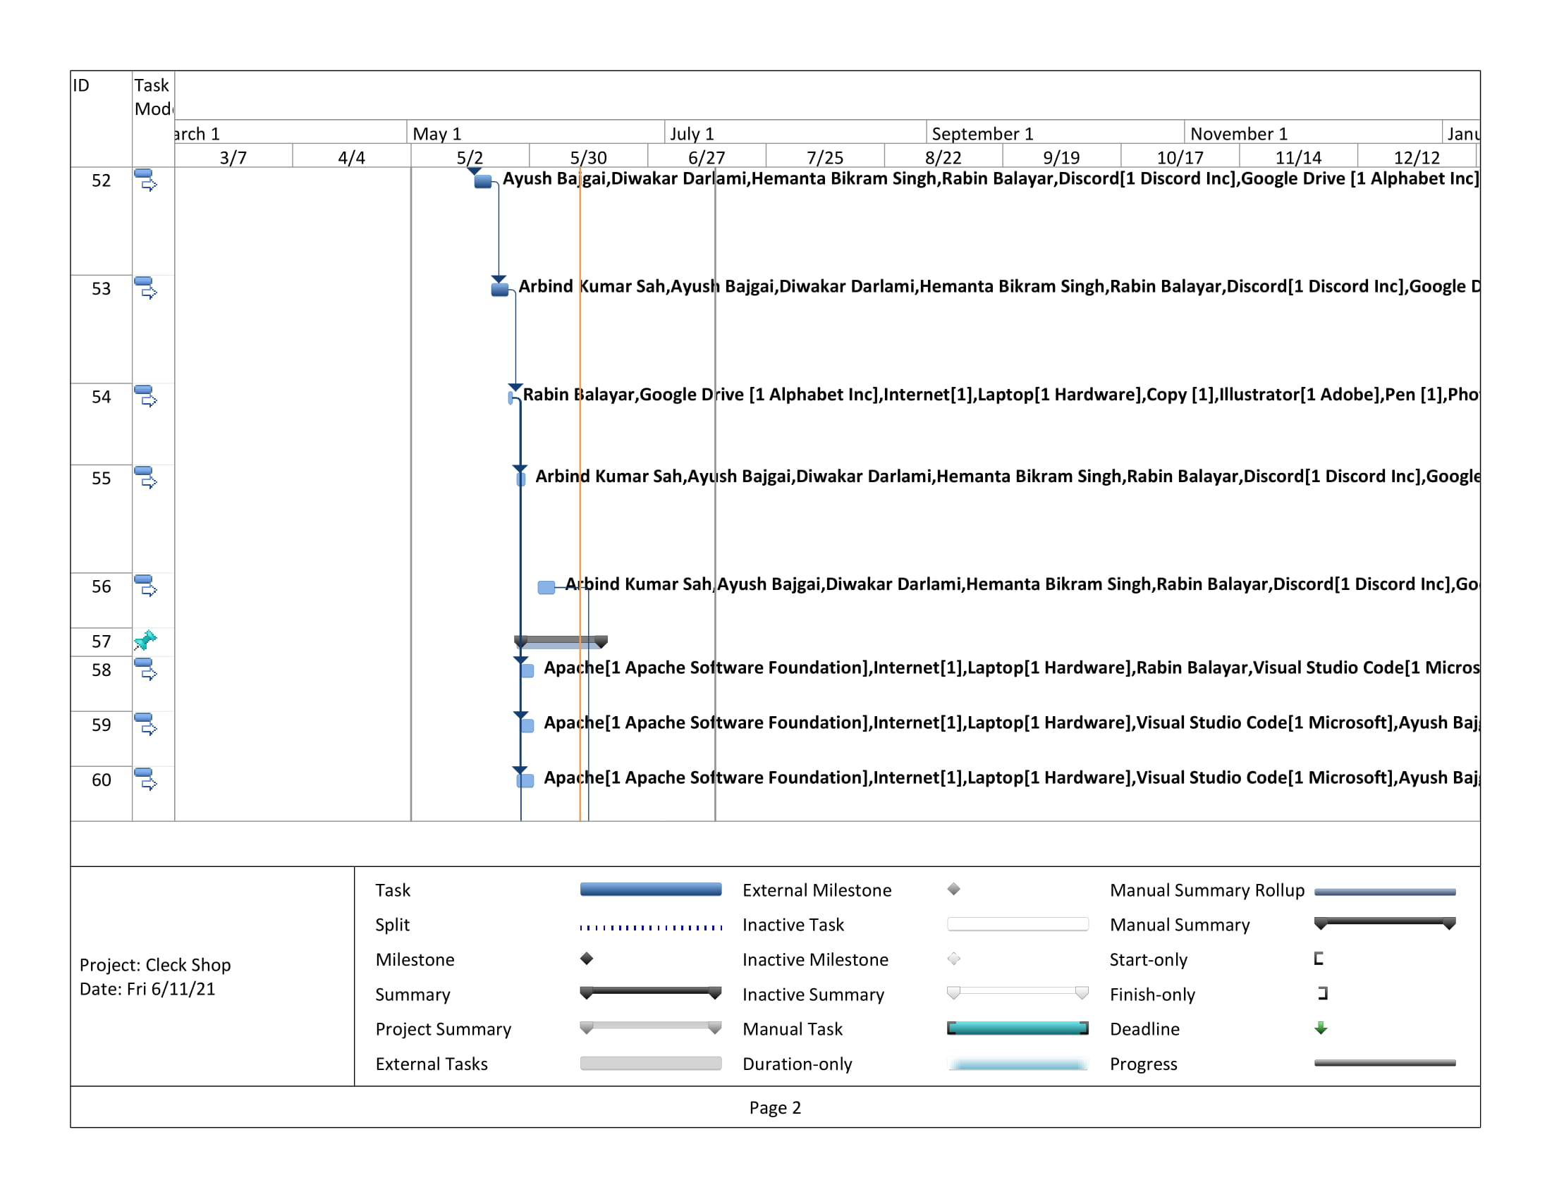

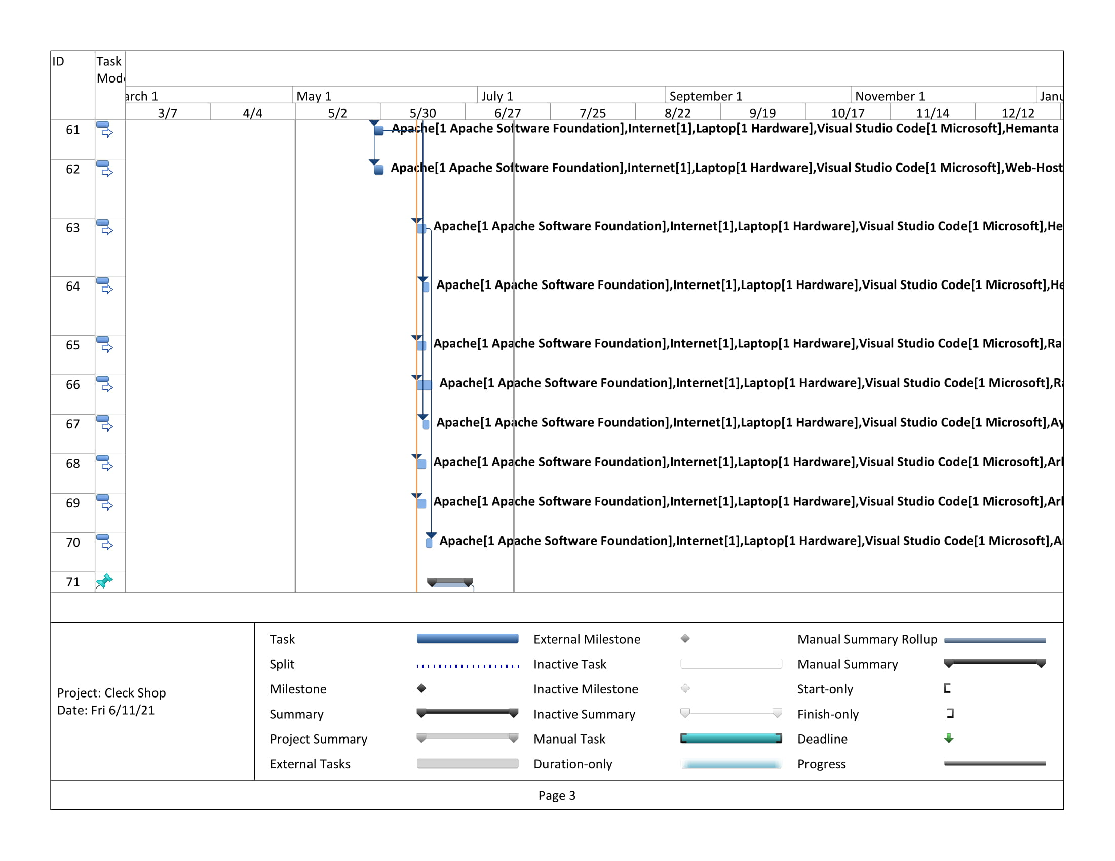

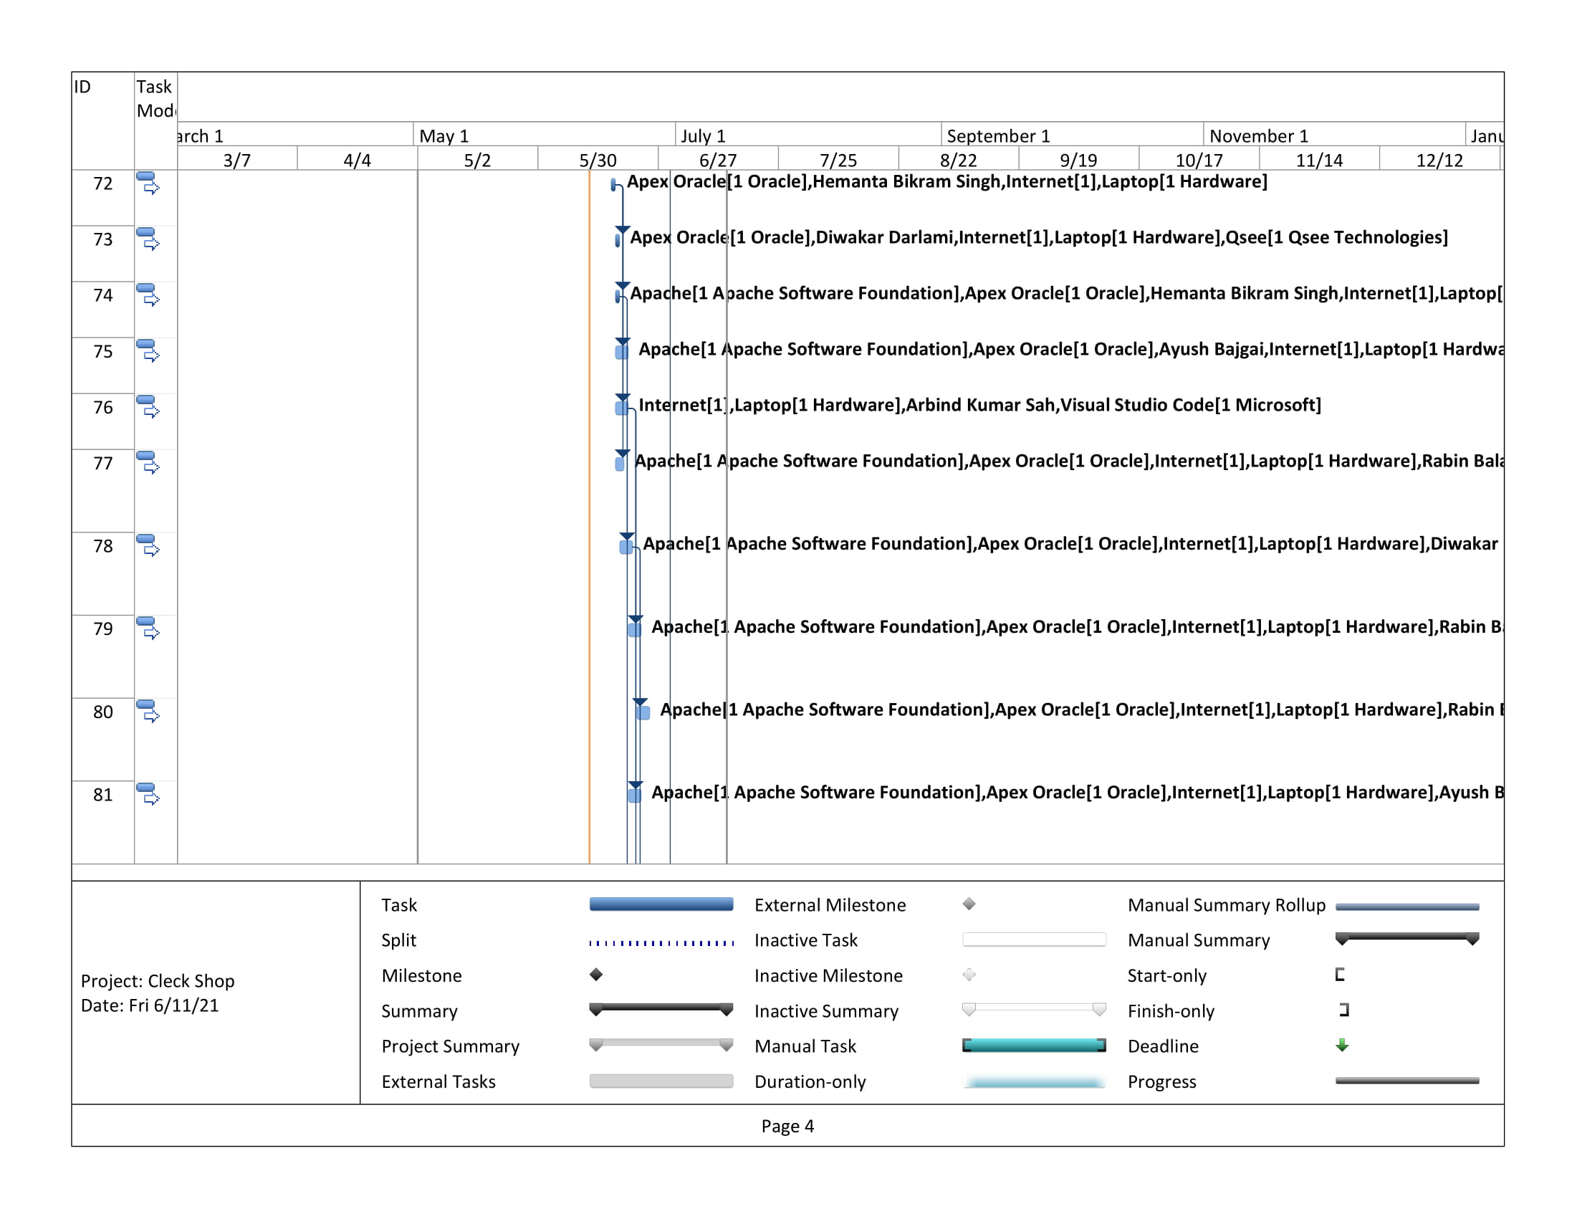

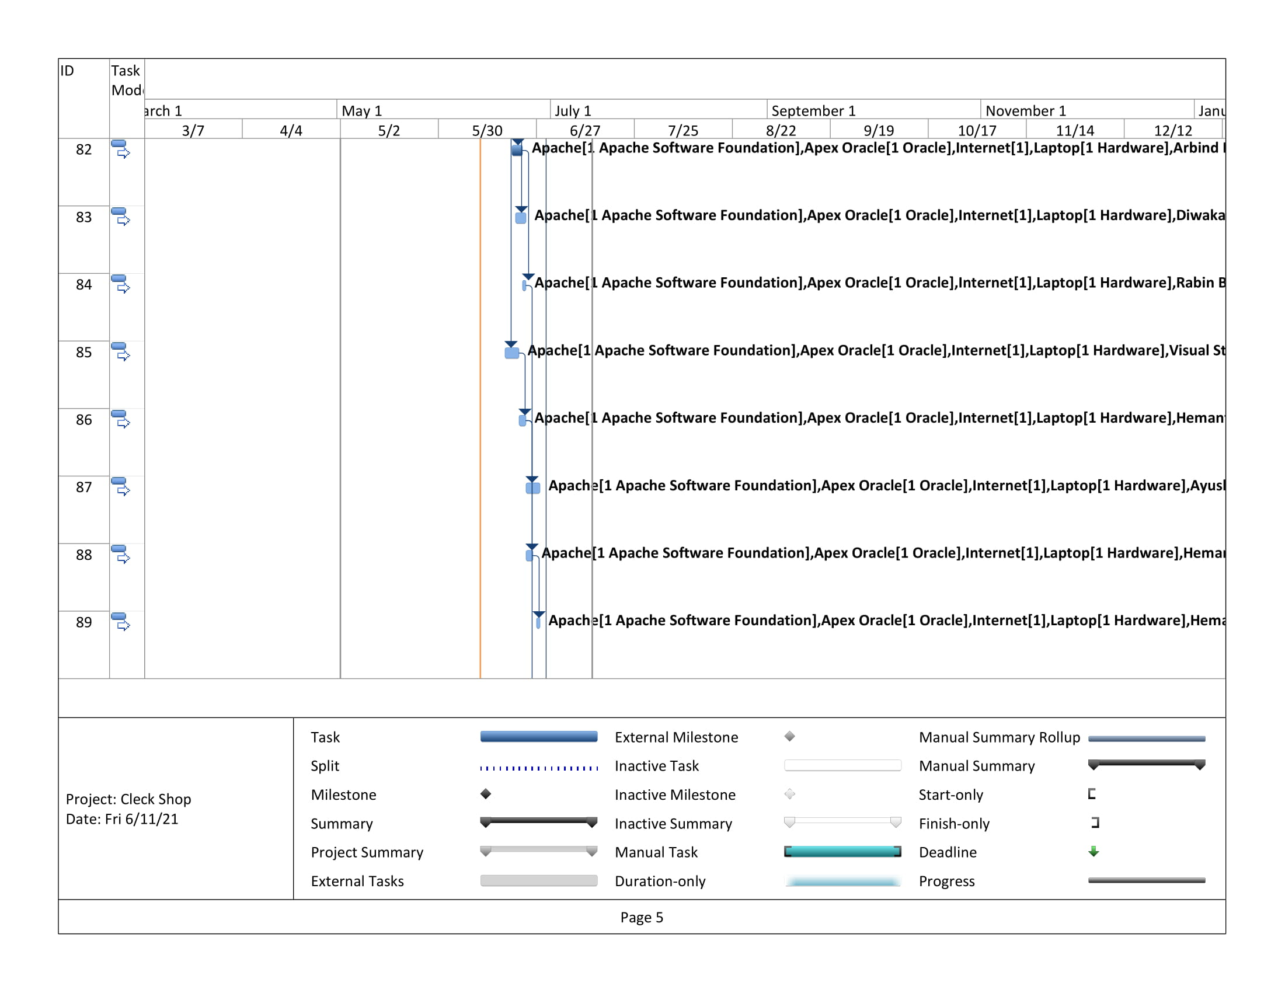

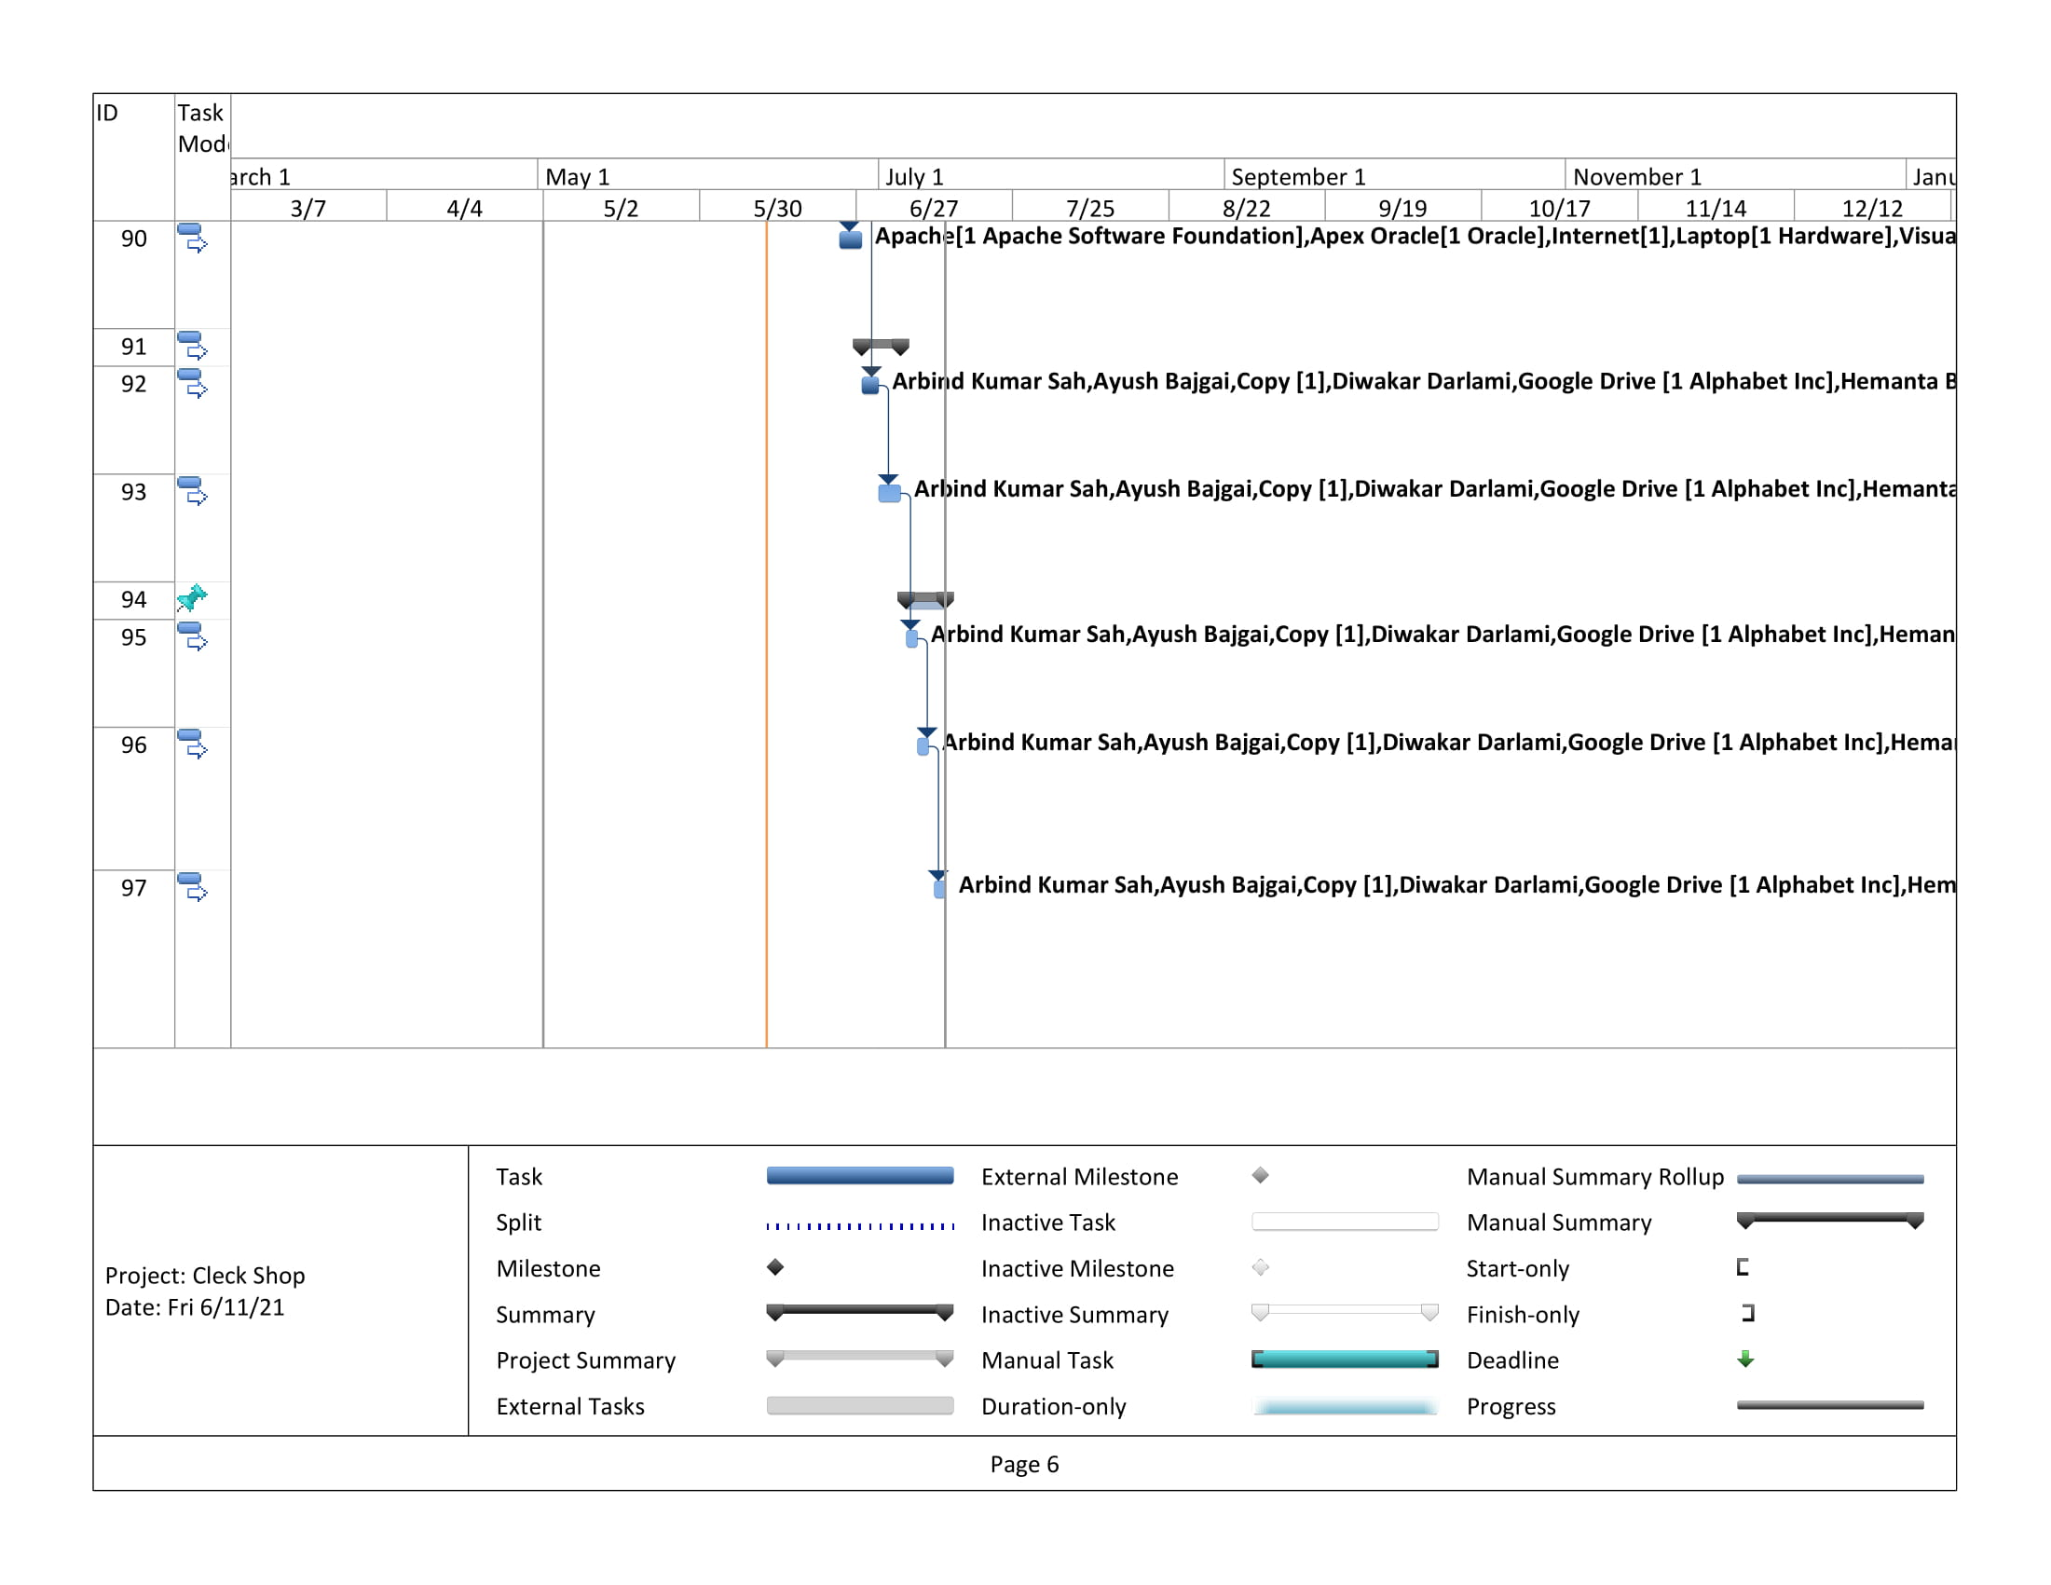

Timeline

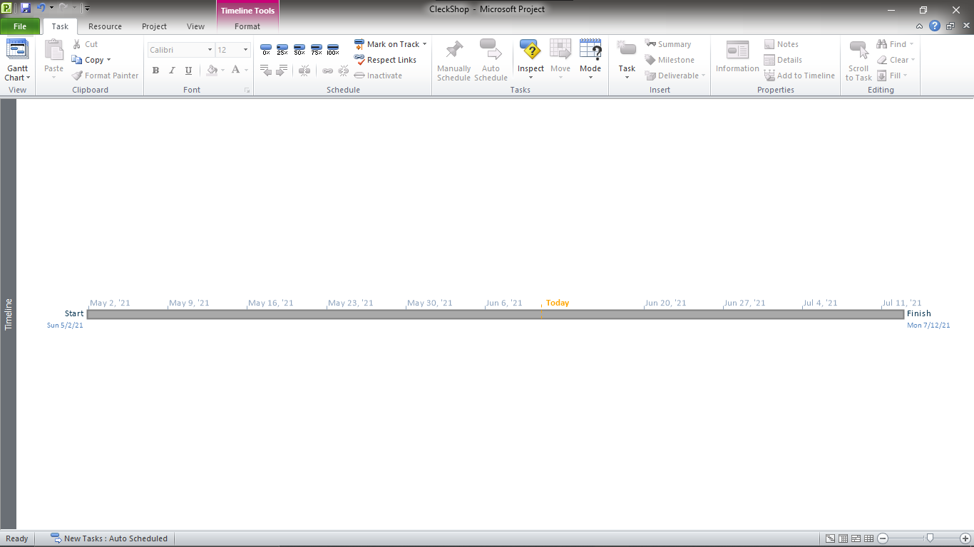

Calendar

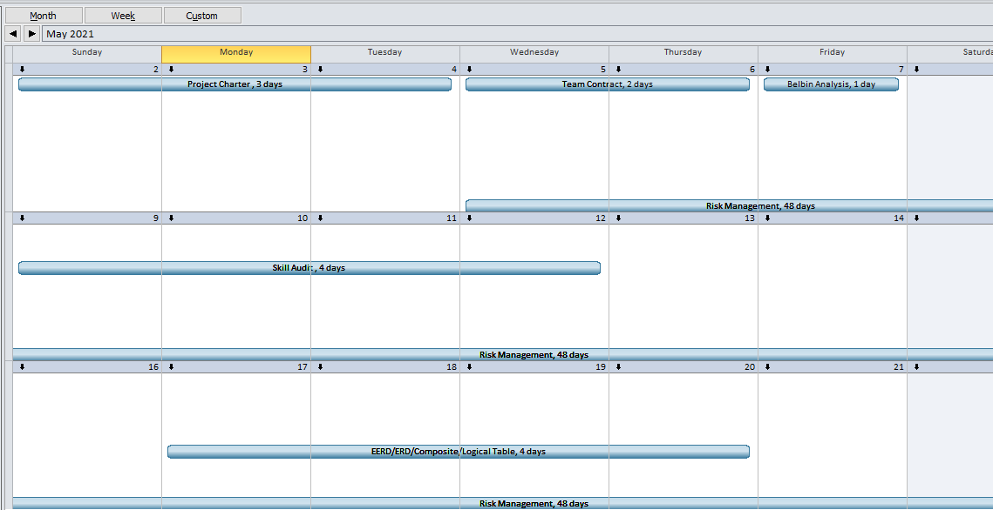

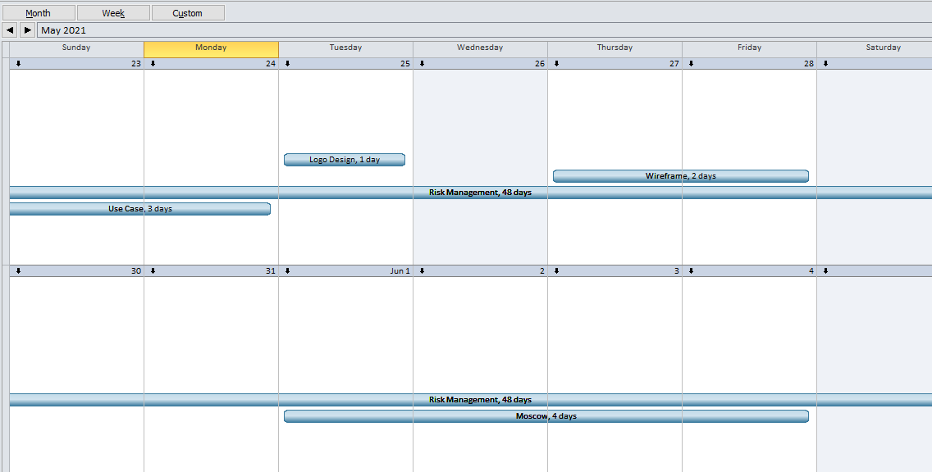

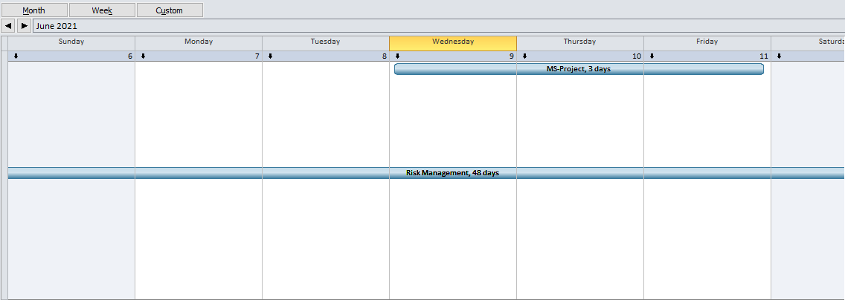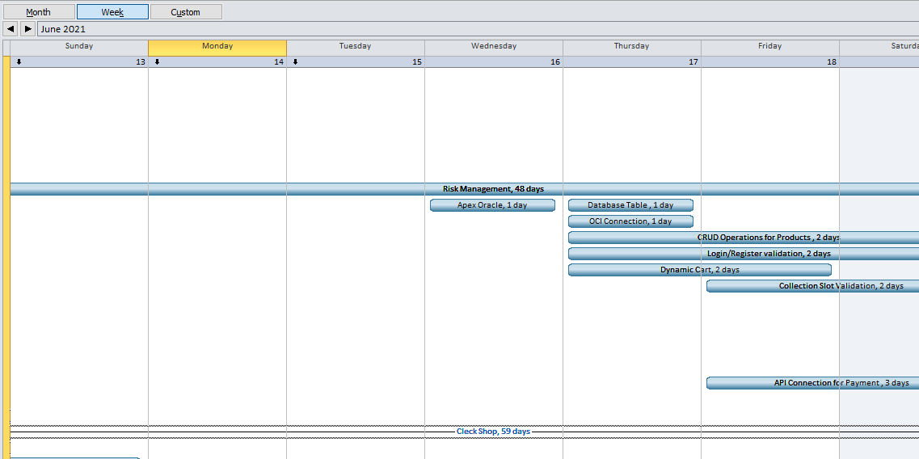

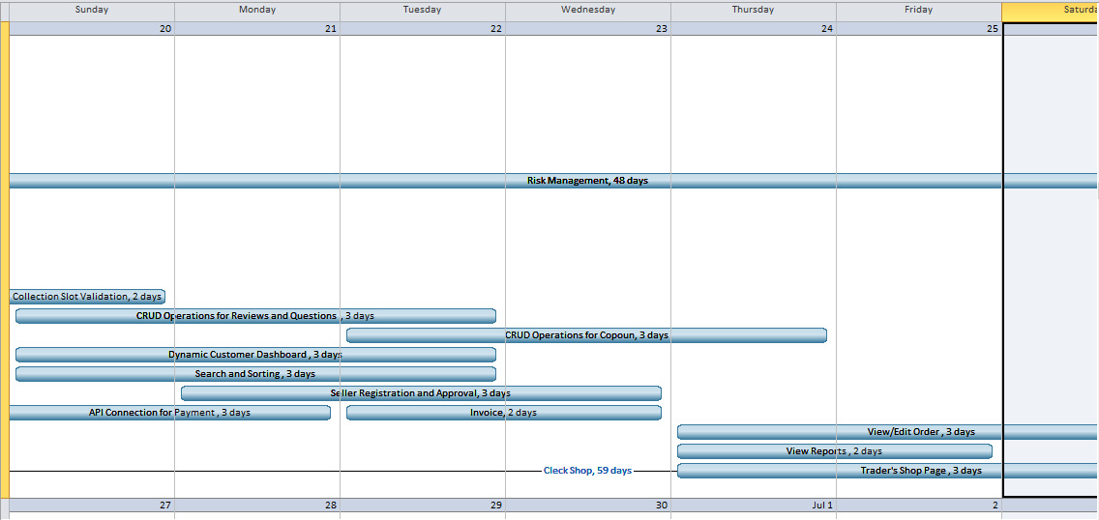

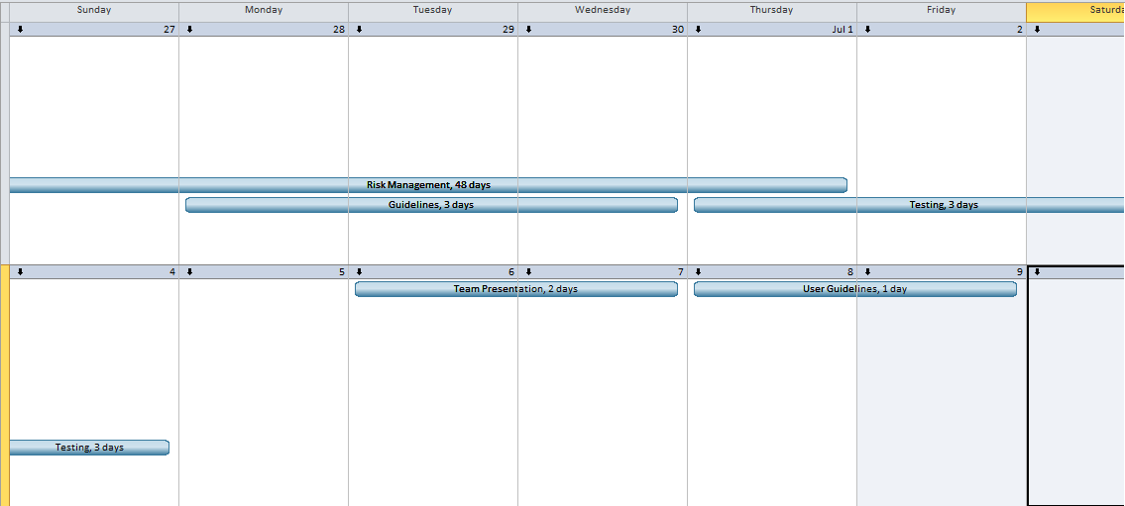

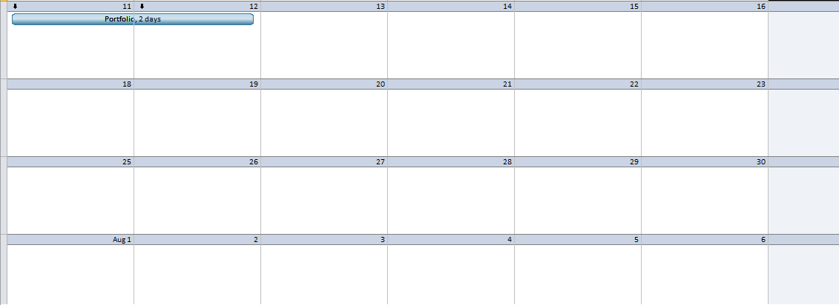

Resource Sheet

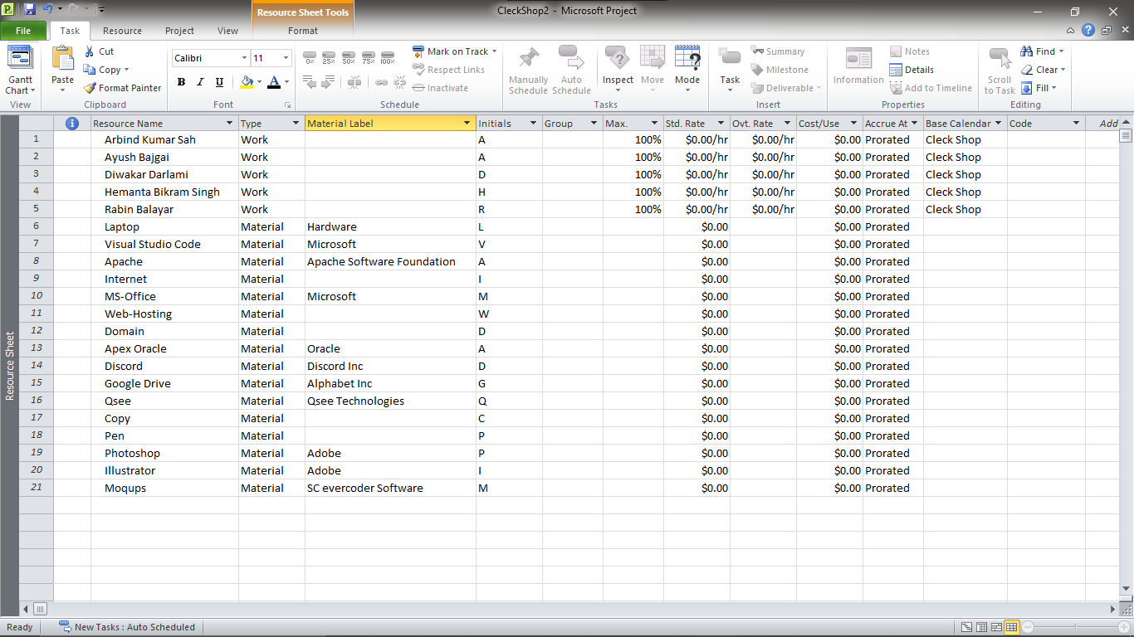

Change Working Time

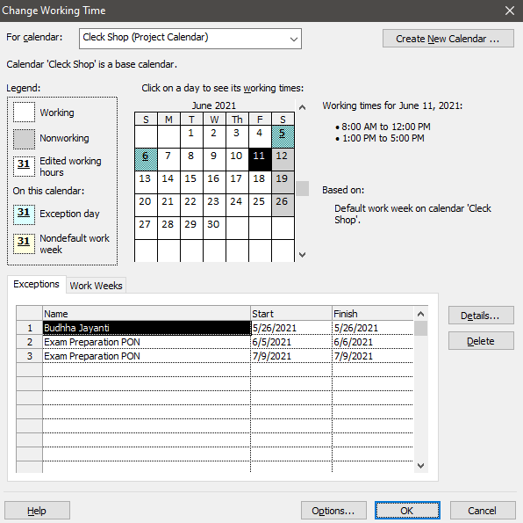

2.4 Communication Tool Used

1) Discord (https://discord.gg/pxpW5V367K)  
2) Gmail  
3) Google Meet (https://meet.google.com/mkw-fhpk-swr)

**3. Execution**

3.1 Entity Relationship Diagram

Extended Entity Relationship Diagram (EERD)

Entity Relationship Diagram(ERD)  
  
Composite ERD

Logical Design

List of tables and foreign keys

**USER** (user_id, user_fullname, user_email, user_mobileNo, user_password)

**CUSTOMER** (user_id, customer_id, customer_dob, customer_gender, customer_address)

**TRADER** (user_id, trader_id)

**ADMINISTRATOR** (user_id, admin_id)

**CART** (cart_id, *customer_id*, purchased, cart_quantity)

**CART_PRODUCT** (cartproduct_id, *cart_id, product_id*, cartproduct_quantity)

**PRODUCT** (product_id, *category_id*, product_name, product_description, product_price, discount_price, product_shortdesc, product_quantity)

**CATEGORY** (category_id, category_name)

**ORDER** (order_id, *cart_id*, collection_date, collection_time, order_status, order_date)

**PAYMENT** (payment_id, *order_id,* payment_type, payment_status)

**INVOICE** (invoice_id, *order_id*)

**COUPON** (coupon_id, *trader_id,* coupon_code, coupon_code, coupon_amt)

**COUPON_REDEEM** (redeem_id, *coupon_id*, *cart_id*)

**REVIEW_QUESTION** (review_question_id, *customer_id, product_id,* review_rating, review_text, question_query, question_answer)

3.2 Use Case Model

Customer UML

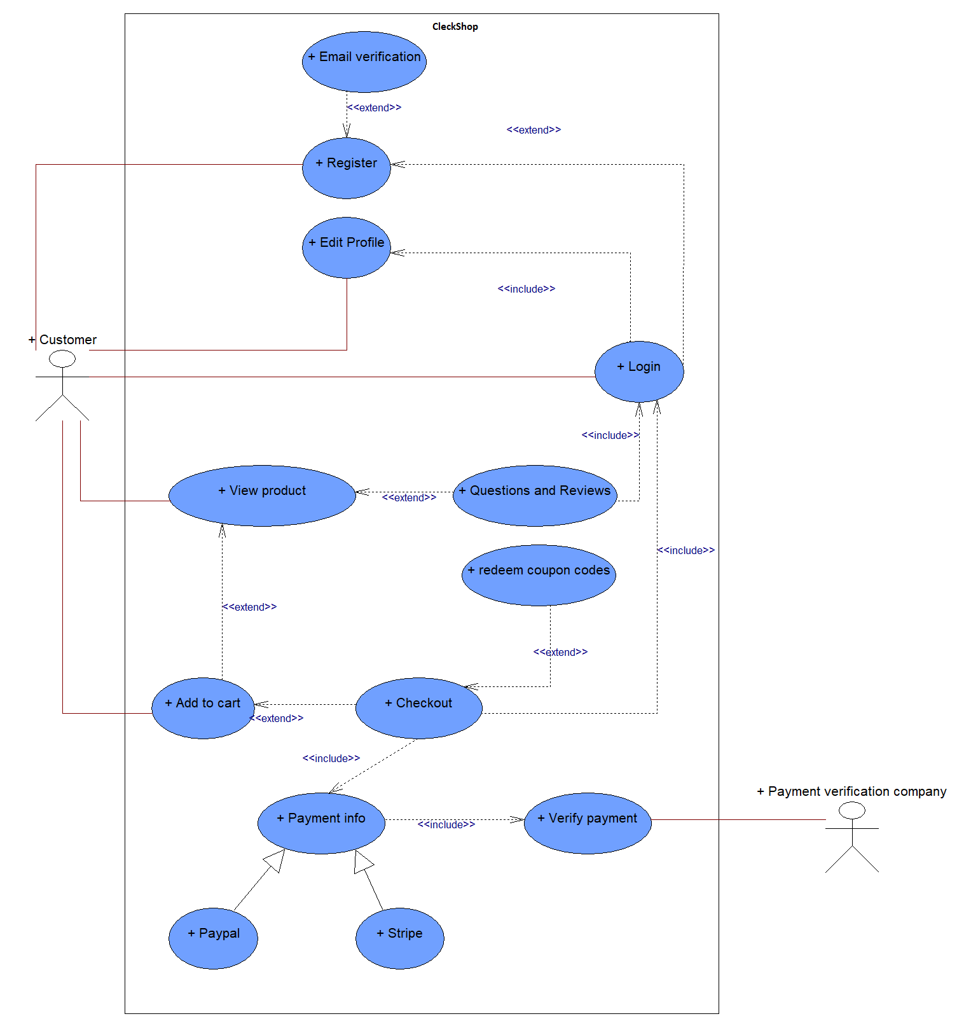

Trader UML

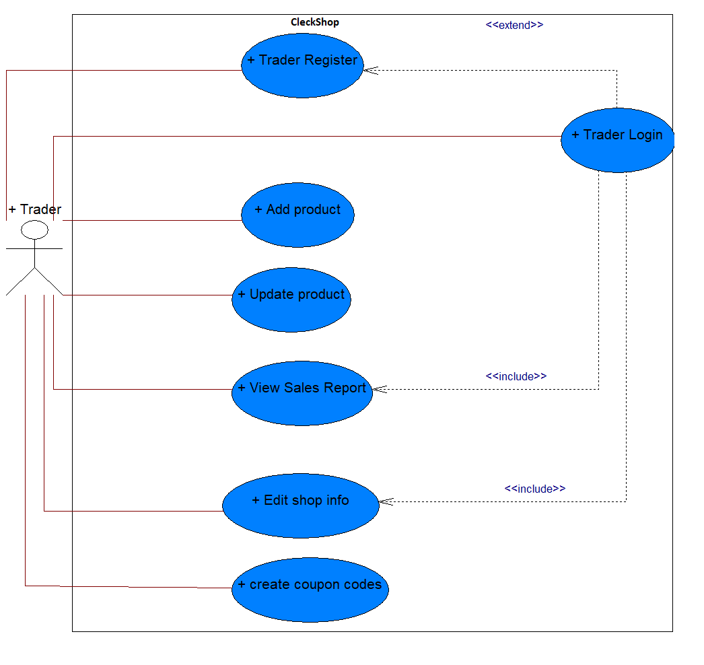

Admin UML

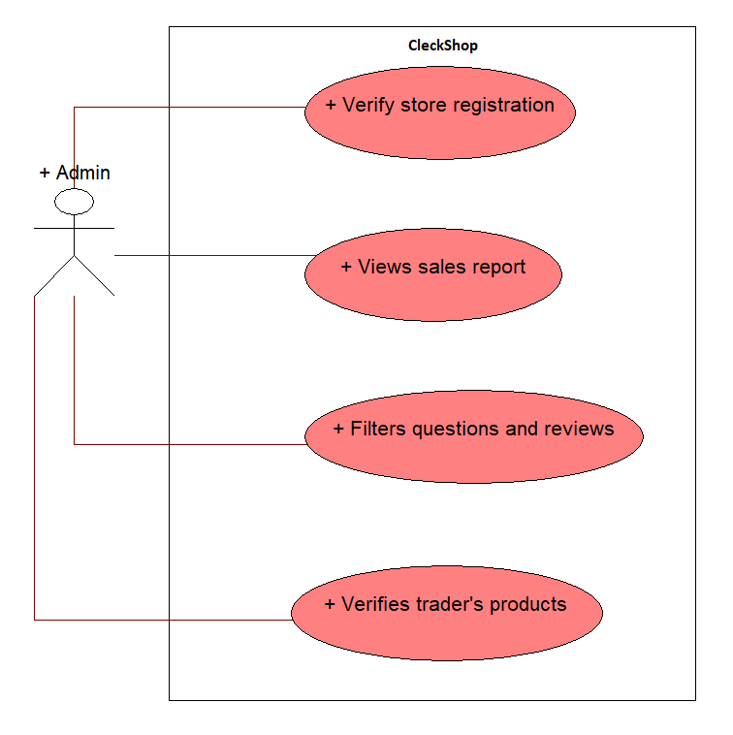

Overall Clerkshop UML

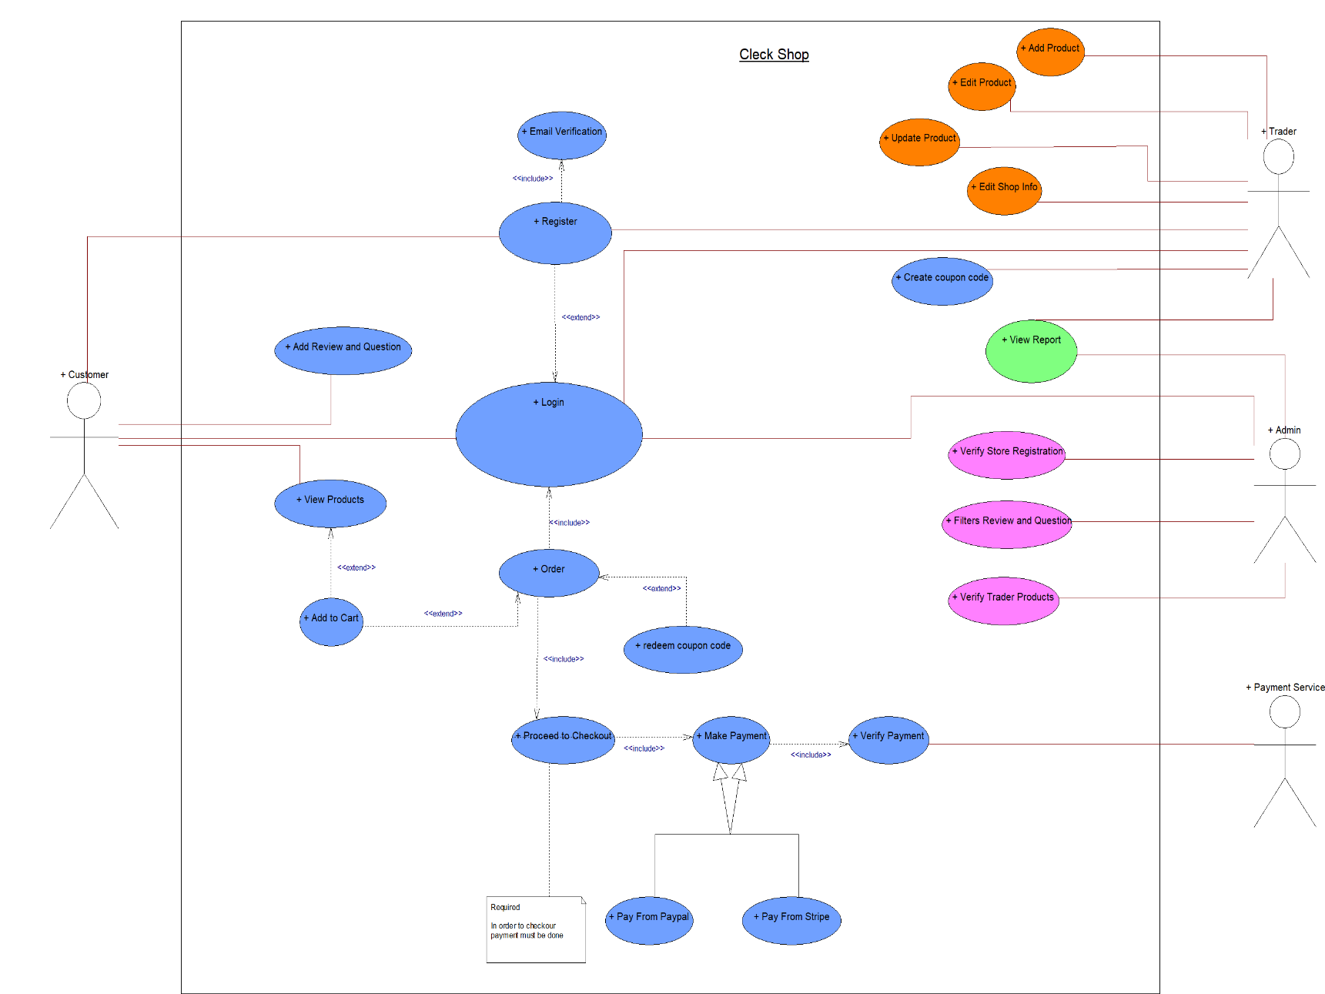

3.3 Requirement Catalogue

**Functional Requirement**

**A.** **Products:**

|  |  |  |
| --- | --- | --- |
| **Requirement ID** | **Description** | **MoSCoW** |
| **A1** | **All product should have details** |  |
| A1-1 | Products should have a unique ID. | M |
| A1-2 | Products should be associated with a trader. | M |
| A1-3 | Products should have a short name, price, stock quantity and an image. | M |
| A1-4 | Products should have short descriptions and descriptions. | S |
| A1-5 | Products can have multiple images. | C |
| A1-6 | Products should have a category. | M |
| A1-7 | Products can have different variants. | W |
| **A2** | **An Interface to view products** |  |
| A2-1 | Products will be displayed with at least 1 image, title, price, shop name, short description and description. | M |
| A2-2 | The Product Page should contain the Add to Cart and Buy Now button. | M |
| A2-3 | Product Page should have a form to choose/enter quantity. | M |
| A2-4 | Products Page can have multiple tabs to view descriptions, questions and reviews. | M |
| A2-5 | Social Media icons for sharing will be displayed. | C |

**B. Customer:**

|  |  |  |
| --- | --- | --- |
| Requirement ID | Description | MoSCoW |
| B1 | Customer |  |
| B1-1 | Customers must have a unique id. | M |
| B1-2 | Customer should be able to login by username and password | M |
| B1-3 | Customer should be able to add to cart | M |
| B1-4 | Customers can provide reviews and questions | C |
| B1-5 | Customers can use coupon code provided by traders | C |
| B1-6 | Customers should be able to add to cart. | M |
| B1-7 | Customers should be able to navigate through different products. | M |
| B1-8 | Customers can share products via social media | C |
| B1-9 | Customers are able to search products via text search | M |
| B1-10 | Customers can sort products by name, price (i.e ascending and descending) filter by maximum and minimum and ratings. | M |
| B2 | Dashboard of Registered Customers |  |
| B2-1 | Customers should be able to view their basic information. | M |
| B2-2 | Customers should be able to update their information like name, email, password and contact number. | M |
| B2-3 | Customers should be able to view their redeem coupons. | M |
| B2-4 | Customers should be able to view their previous order history and payments | M |
| B2-5 | Customers can view their reviews and questions provided to the products | M |
| B2-6 | Customers can change their password through OTP verification through email | M |
| B3 | Registration system |  |
| B3-1 | Customers should fill their required information like full name, address, email, password, contact number, gender, date of birth | M |
| B3-2 | Customer must agree to terms and conditions of Cleck Shop | M |
| B3-3 | Verification link is sent via provided email for confirmation. | M |
| B3-4 | Passwords should have 8-12 characters, 1 special character, 1 number and at least 1 capital letter. | M |
| B4 | Order and Cart system |  |
| B4-1 | Registered customers are able to proceed to checkout via cart | M |
| B4-2 | Customers can increase or decrease the quantity inside cart | C |
| B4-3 | Cart can store upto 20 products | M |
| B4-4 | Customers can be able to use their coupon during checkout | C |
| B4-5 | Customer can remove the products from the carts | M |
| B4-6 | Cart is saved even if they logged out from the system | M |
| B5 | Checkout and Payment System |  |
| B5-1 | Customers should login in order to checkout | M |
| B5-2 | Customers can pay via Paypal and stripe | M |
| B5-3 | Customers should receive invoice through email | M |
| B5-4 | Customers should be able to choose a collection slot before ordering. | M |

**C. Trader:**

|  |  |  |
| --- | --- | --- |
| **Requirement ID** | **Description** | **Moscow** |
| **C1** | **Login and Register for Trader** | **M** |
| C1-1 | Traders must have a different login panel. | M |
| C1-2 | A trader must input full name, address, mobile no, email, shop name, company registration number, shop logo and shop description for registration. | M |
| C1-3 | Traders must have a unique id. | M |
| C1-4 | Confirmation of the traders email is done via OTP. | M |
| **C2** | **Dashboard of Traders** |  |
| C2-1 | Traders will login to the oracle dashboard to view orders and stock availability. | M |
| C2-2 | Traders will get weekly and monthly reports of orders, payments. | M |
| C2-3 | Traders will have one shop. | S |
| C2-4 | Traders can perform create, update and delete operations on the products. | M |
| C2-4 | Traders should be able to update their information like name, email, password, contact number and shop details. | M |
| C2-5 | Traders can generate coupons on specific products. | C |
| C2-6 | Traders can provide discount on specific products | C |
| **C3** | **Payments** |  |
| C3-1 | Traders will get a monthly report of product sales and total income. | M |
| C3-2 | Traders will receive invoice through email of the products sold. | M |

**D. Management:**

|  |  |  |
| --- | --- | --- |
| **Requirement** | **Description** | **Moscow** |
| **D1** | **Login system** |  |
| D1-1 | Management should login to the oracle dashboard. | M |
| **D2** | **Admin role** |  |
| D2-1 | Management should be able to look over traders and customer’s accounts. | M |
| D2-2 | Management could approve traders' accounts. | M |
| D2-3 | Management can deactivate the traders account | C |
| D2-4 | Management should verify trader products for uniqueness. | M |
| D2-5 | Management can remove vulgar reviews. | S |
| D2-6 | Management can disable coupons. | S |
| D2-7 | Management can disable trader products. | S |
| **D3** | **Dashboard** |  |
| D3-1 | Management should be able to view the report of traders sales. | M |
| D3-2 | Management dashboard should have an order graph. | M |
| D3-3 | Management dashboard should have top 5 traders. | S |
| D3-4 | Management dashboard should display total customers. | M |

**Non-functional Requirement**

* The website should be able to support 10,000 users at a time.
* The site should be able to fully load under 3.5 seconds.
* The UX/UI should be clean, simple, easy to navigate and ad free.
* SSL certificates should be installed and the sha256 algorithm should be used for encryption.
* The code and the files should be well organized so that the site can be easily maintained and bugs can easily be fixed.
* The server should have enough space to store enough data, images and videos.
* The website should be responsive on all devices.
* The website should be compatible in most platforms and browsers.

3.4 Logo Design

3.5 Wireframe

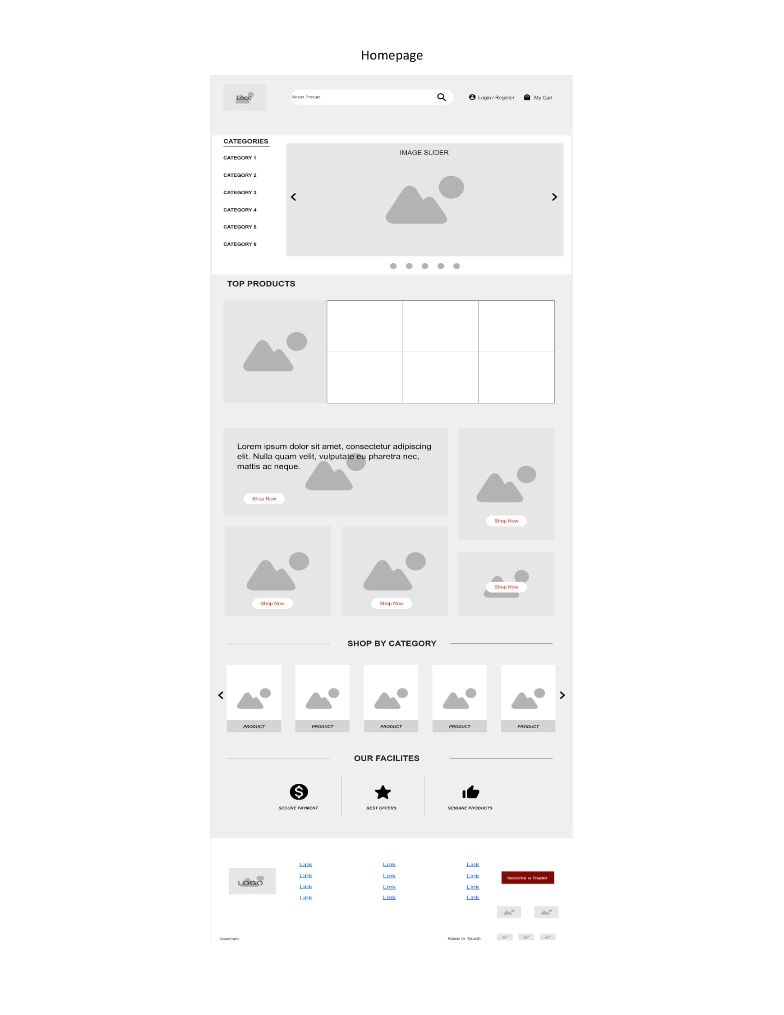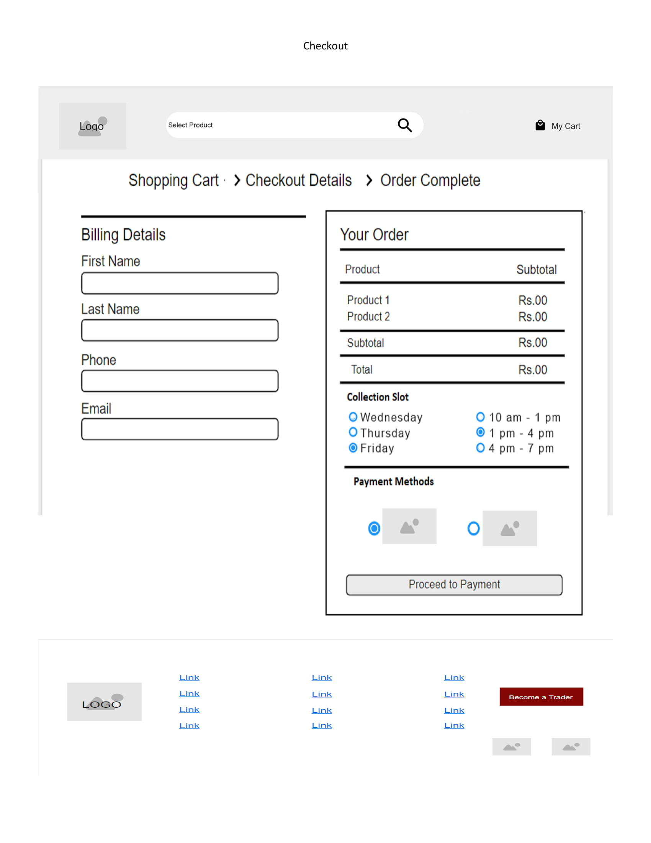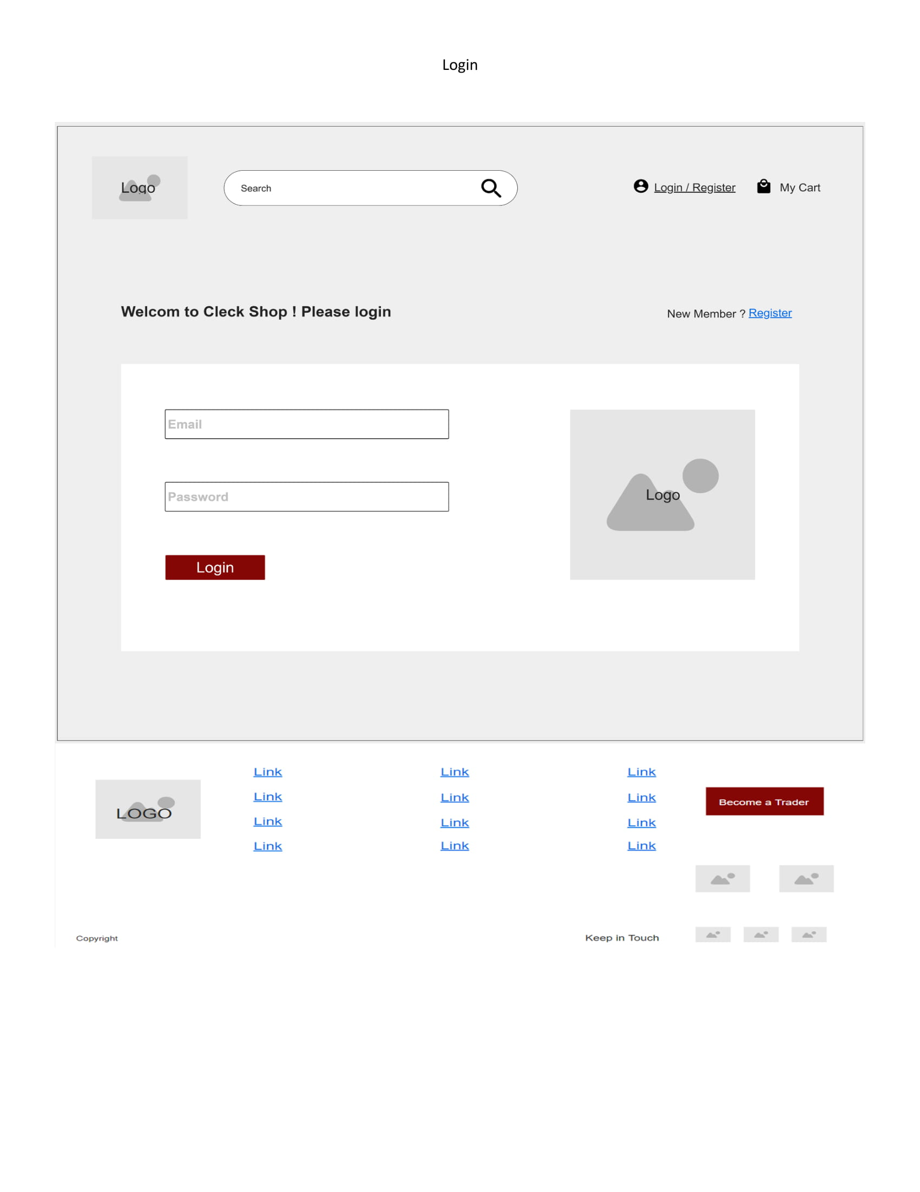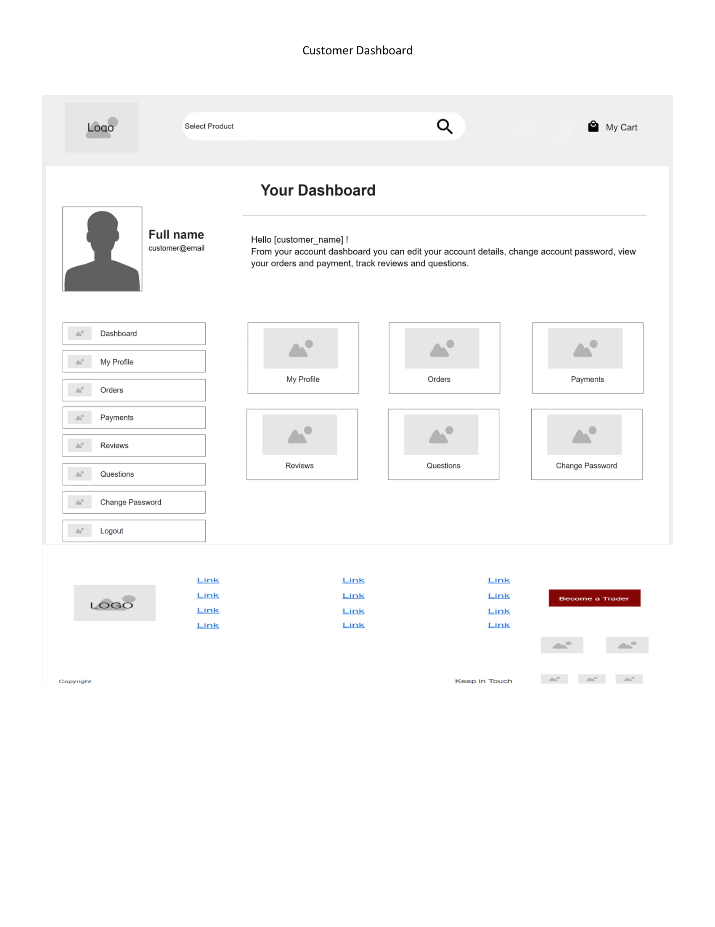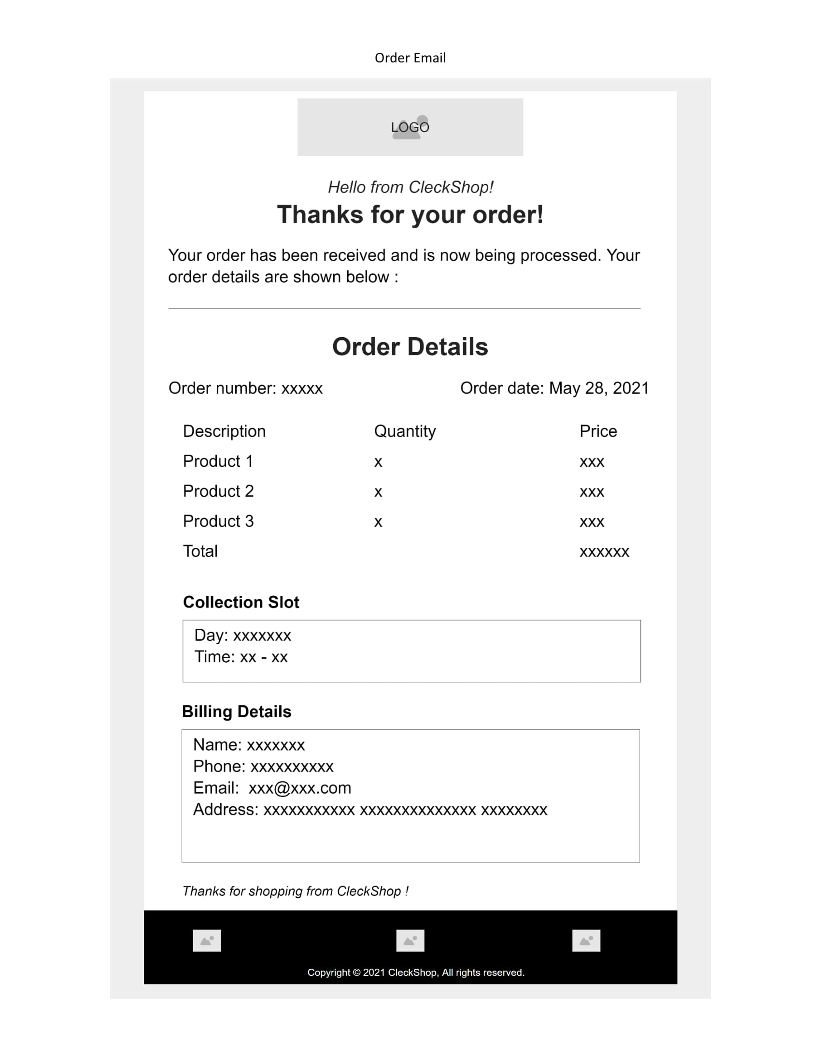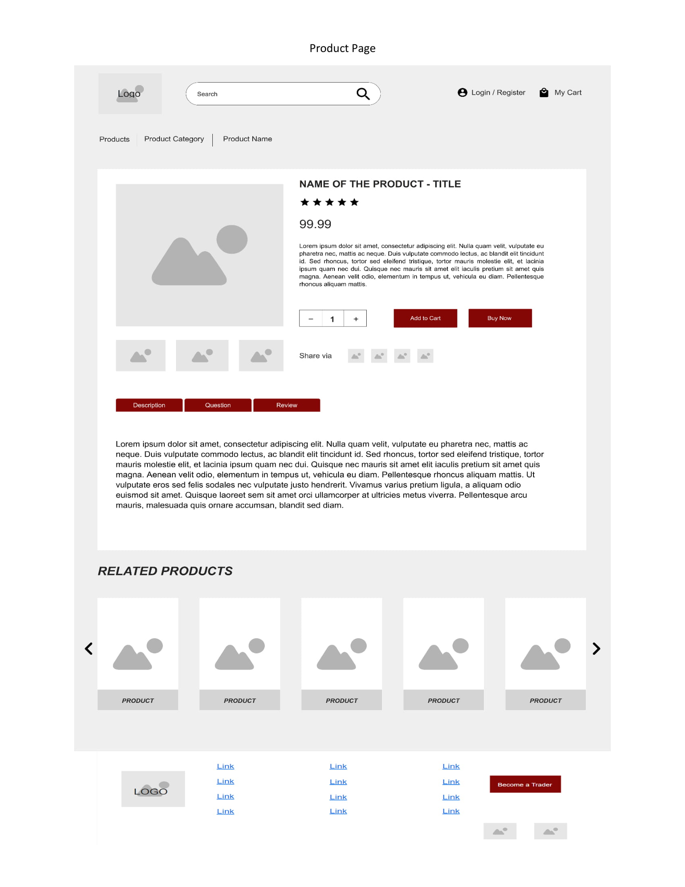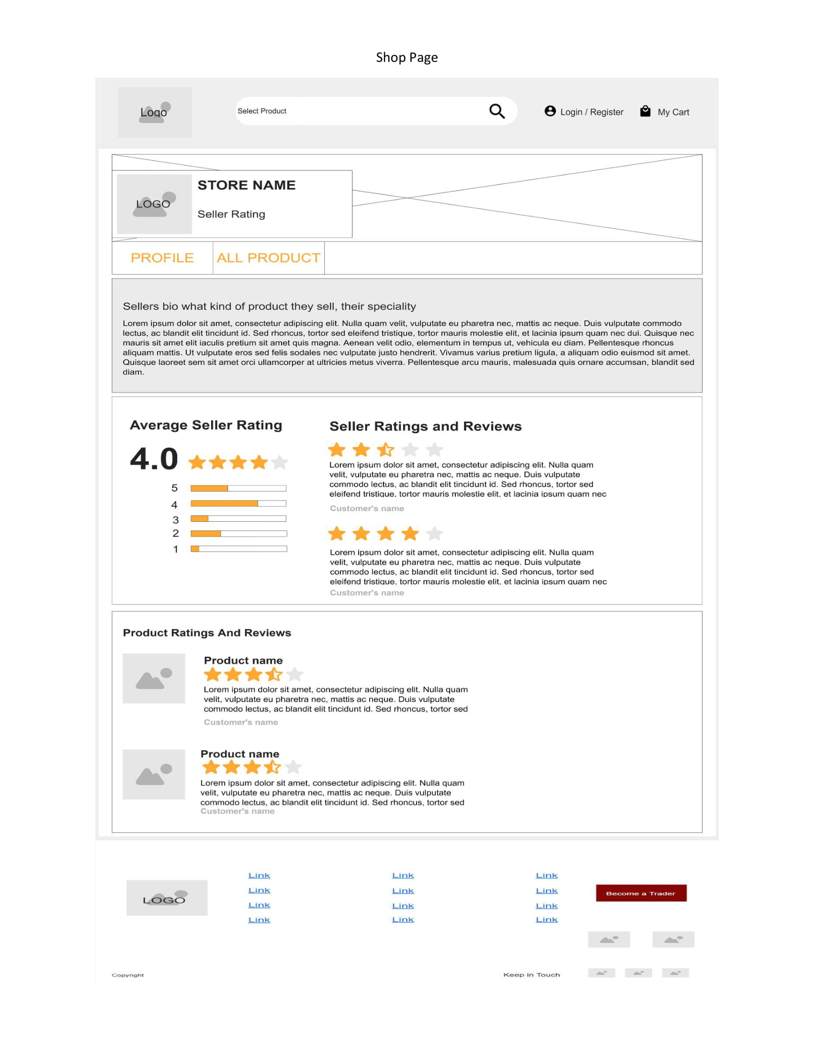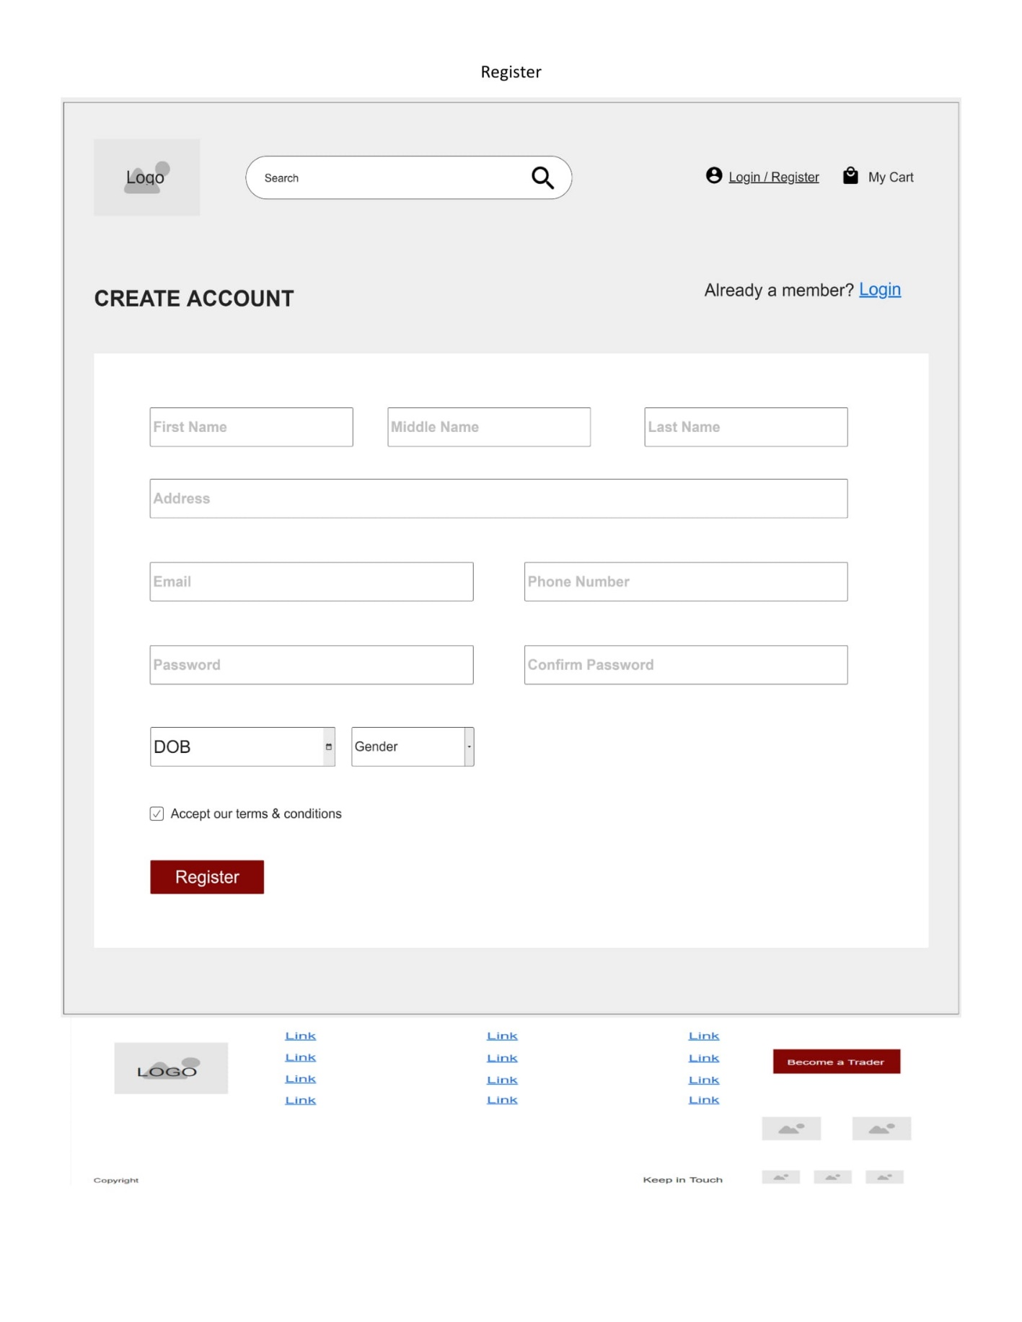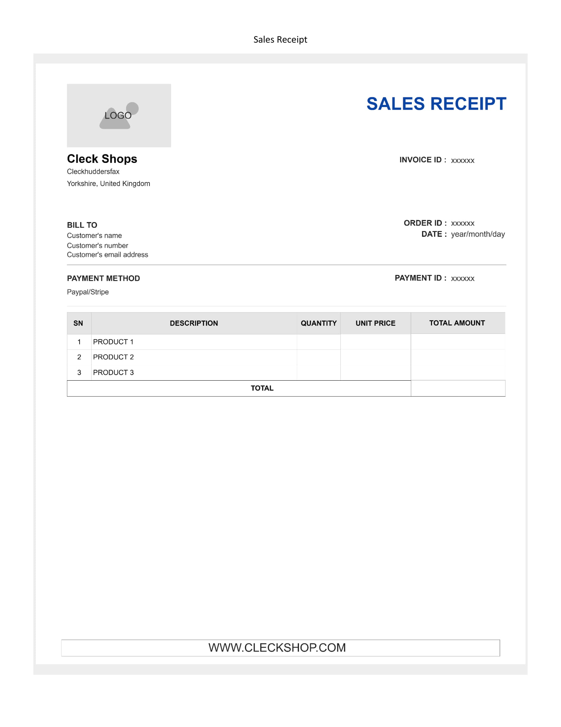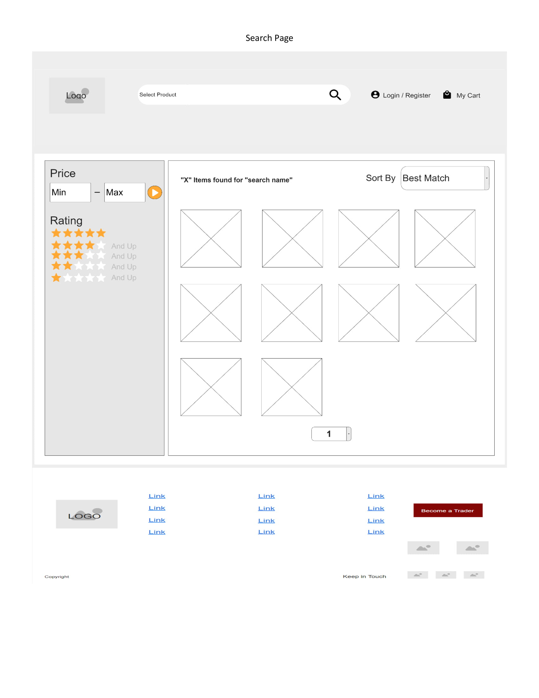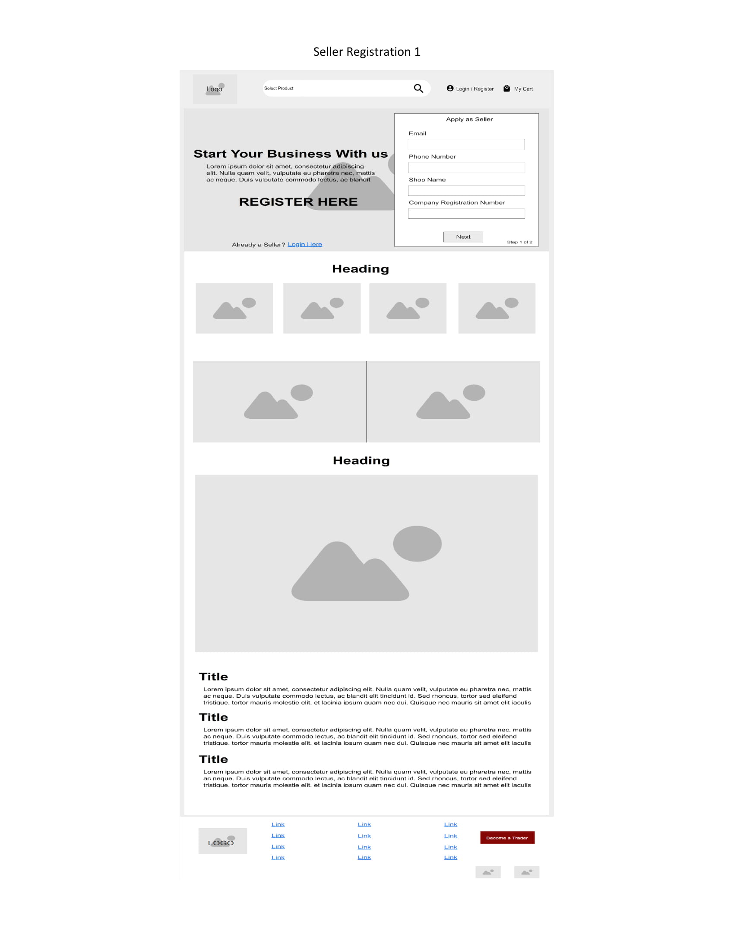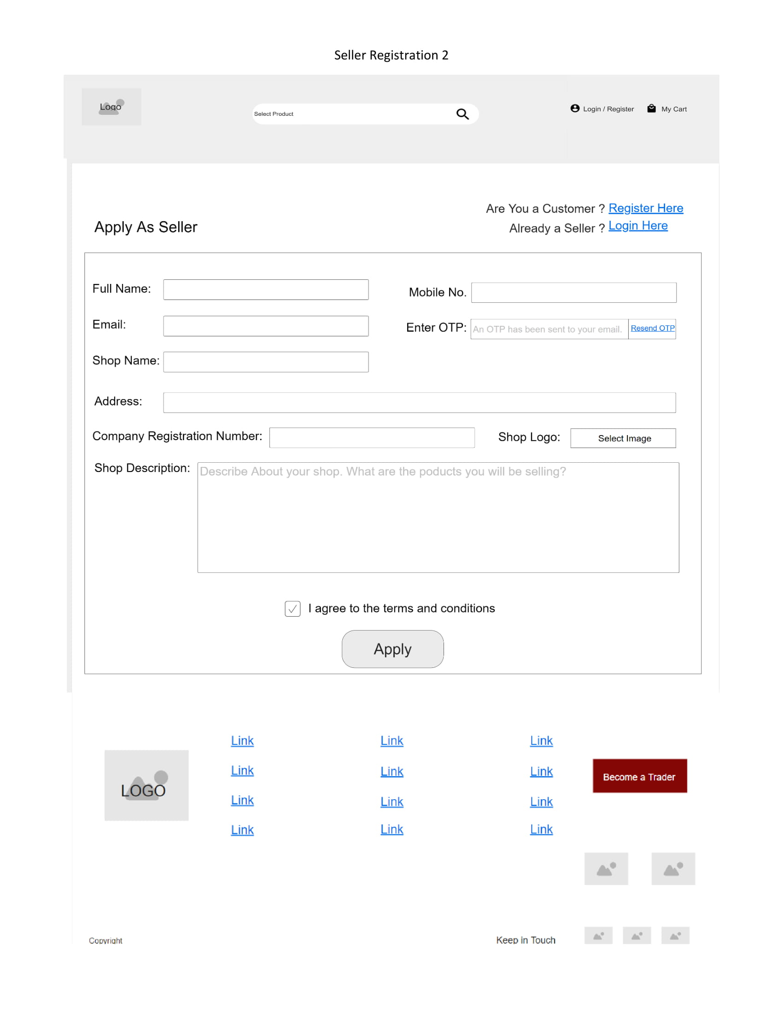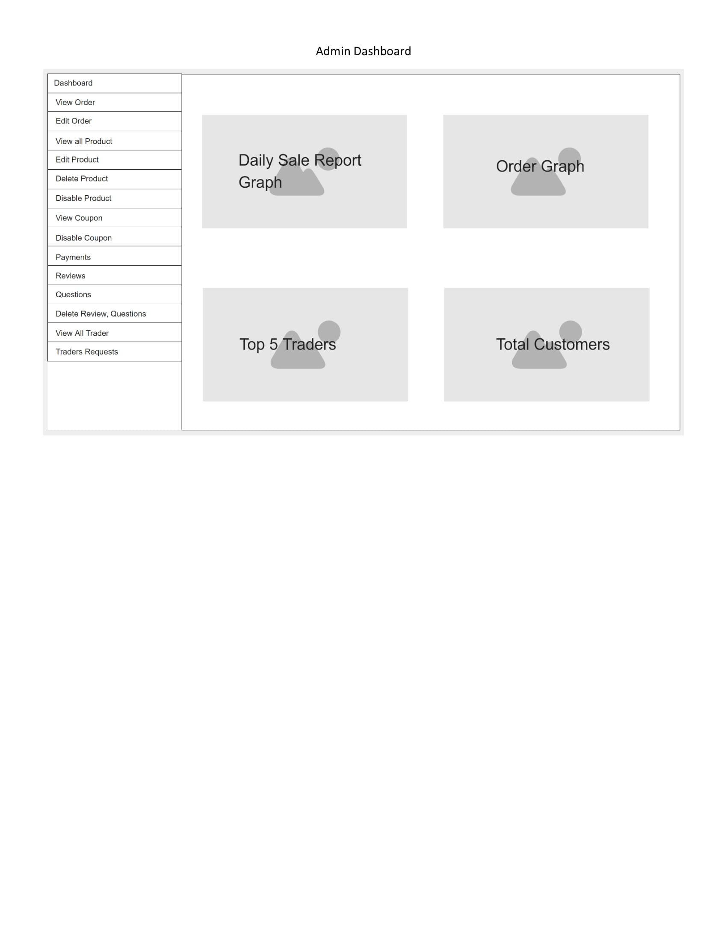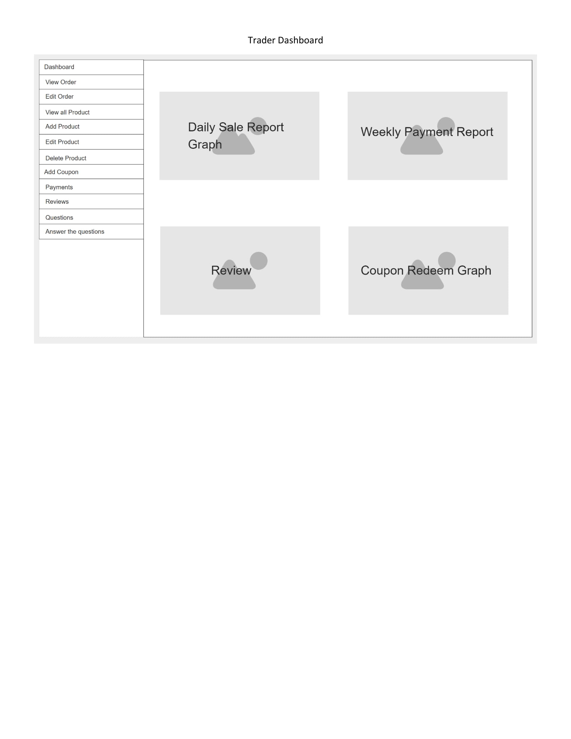

* 1. Product Development

Checkout Page  
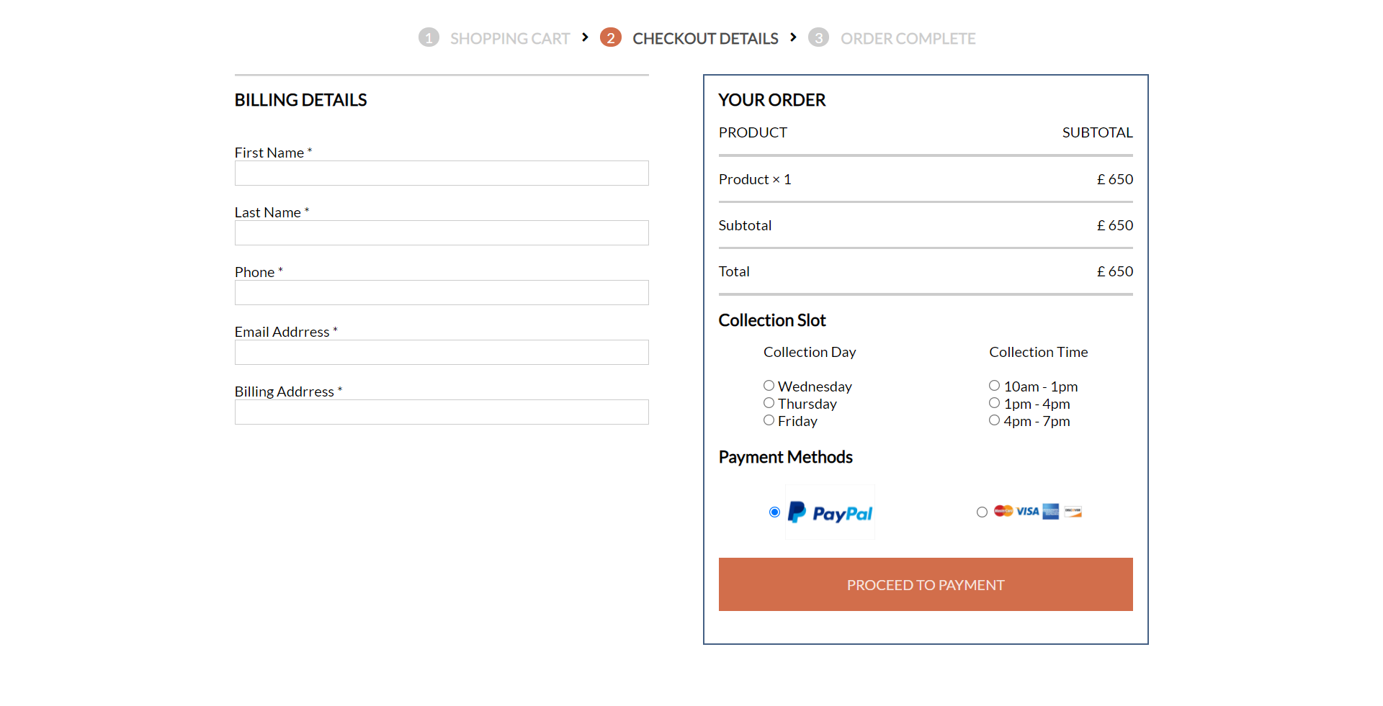

Cart Page

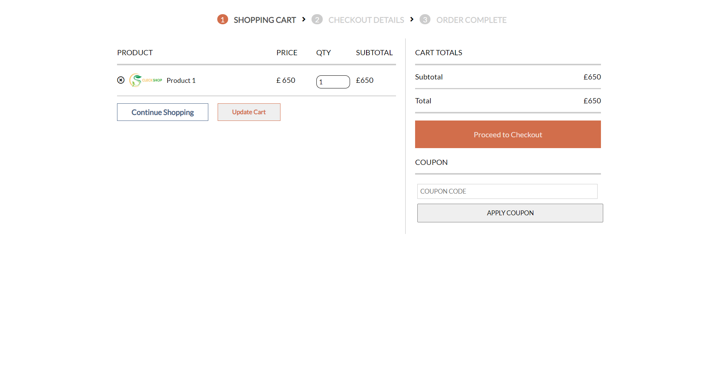

Customer Register Page 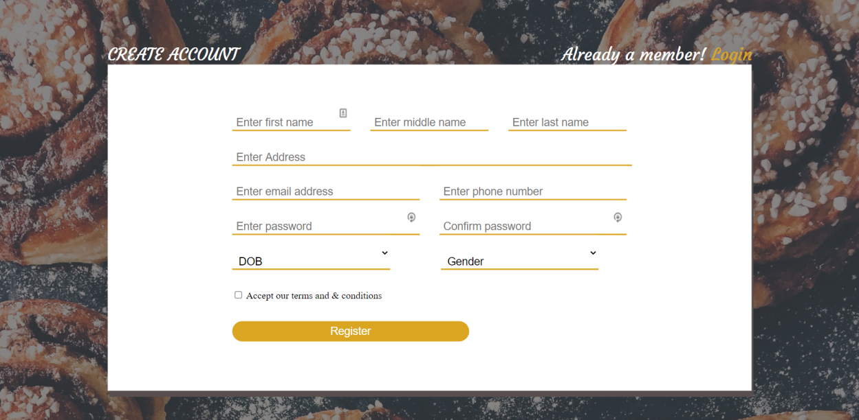

Product Page  
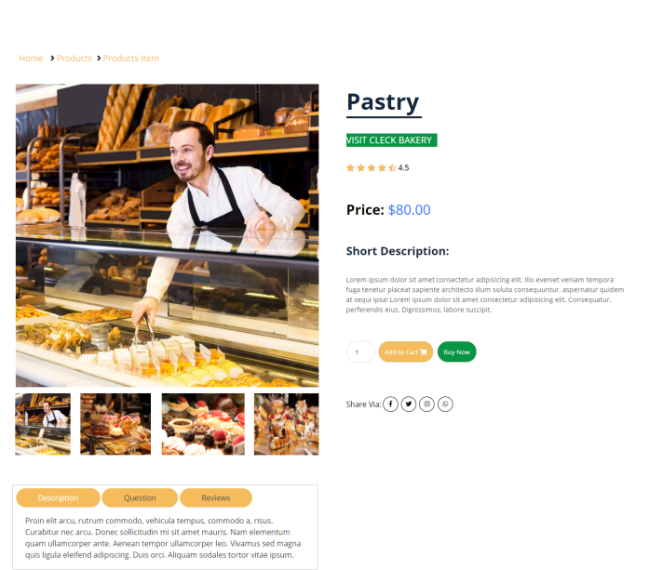

Customer Login Page

